Additional file 1.
Fig. S1. Cornea, but not conjunctiva, is highly innervated by TRPM8 sensory fibers. (A) TRPM8-expressing sensory fibers (green) densely innervate the cornea from Trpm8^{EGFPf/+} transgenic mice. (B) Conjunctiva is seldom innervated by TRPM8⁺ fibers. White arrows indicate Trpm8^{EGFPf/+} fiber axons go through the conjunctiva under the mucosa layer. Scale bar: 250μm.
Fig. S2. The cell bodies of sensory fibers innervating the upper eyelid and cornea are located in the V1 ophthalmic branch of the trigeminal ganglion. (A) WGA-Alexa Fluor® 555 labeled trigeminal neurons for upper eyelid. (B) WGA-Alexa Fluor® 488 labeled trigeminal neurons for the cornea. (C) Merge of the fluorescence in the same trigeminal ganglion section. Scale bar: 100μm.

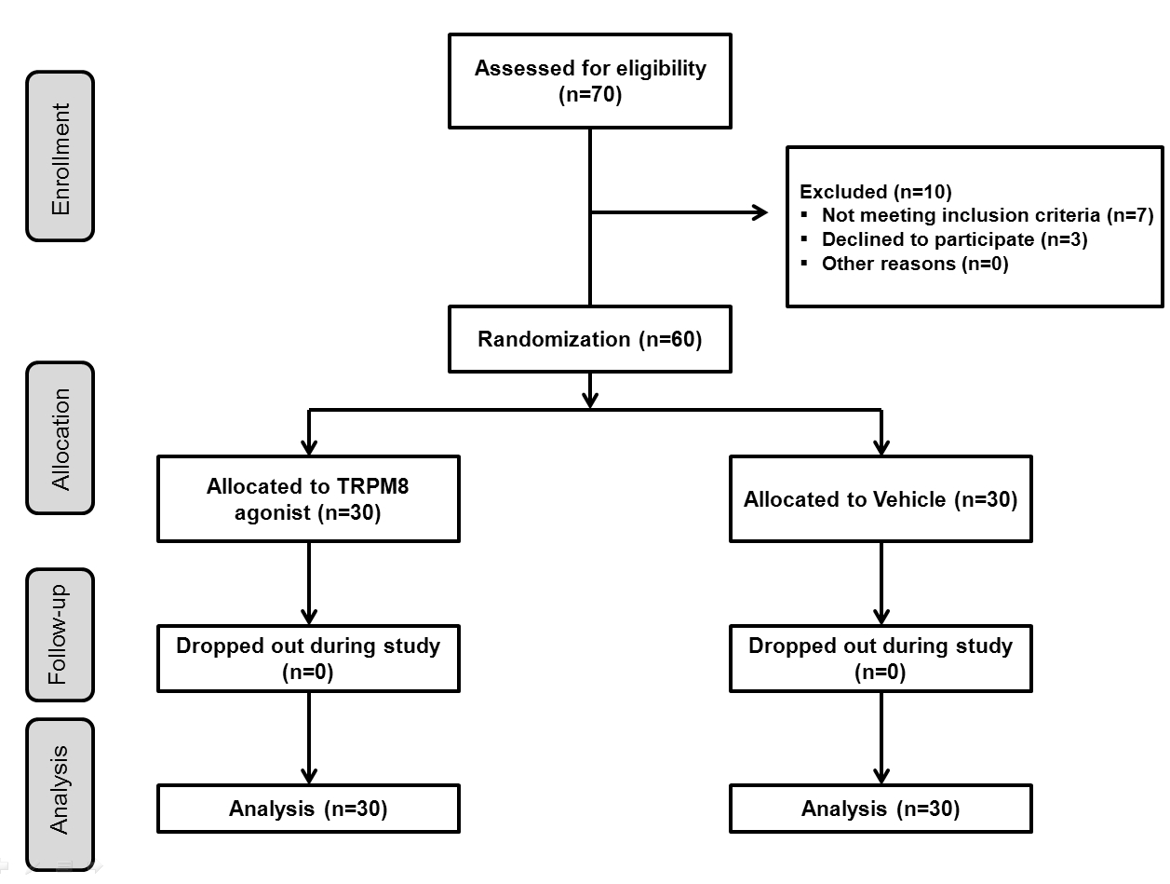Fig. S3. Flow diagram for the design of Expt 1. Subjects received a single application of C3, 2 mg/mL, wiped across the upper eyelid with a gauze pad.

Fig. S4. Flow diagram for the design for Expt 2. Subjects received 14 applicators containing 1 mL of C3, 2 mg/mL, and instructions to wipe the applicator across the upper eyelid four times a day at 6 hr intervals.

Table S1. EC₅₀ and relative potency of compounds on TRPM8. The EC₅₀ of the more potent compounds, 1-diisopropylphosphoryl-C₇ to C₉ and 1-di-sec-butylphosphoryl-C₅ to C₈ fell within a narrow range with overlapping 95% Confidence Intervals. By contrast, structural modifications to the diisobutylphosphoryl moiety or branching of the alkane group to 3-methyl-pentane resulted in a significant loss of activity.
Chemical | EC₅₀ µM | 95% CL | I-Menthol
l-menthol | 3.8 | 2.5 to 5.6 | 1.0
1-diisopropylphosphoryl-pentane | 5.6 | 4.4 to 7.2 | 0.7
1-diisopropylphosphoryl-hexane | 2.4 | 1.5 to 4.0 | 1.6
1-diisopropylphosphoryl-heptane | 0.7 | 0.5 to 1.0 | 5.4
1-diisopropylphosphoryl-octane | 0.7 | 0.5 to 1.0 | 5.4
1-diisopropylphosphoryl-nonane | 0.9 | 0.4 to 2.5 | 4.0
1-di-sec-butylphosphoryl-4 | 14.5 | 7 to 29 | 0.3
1-di-sec-butylphosphoryl-pentane | 1.7 | 1.0 to 2.9 | 2.2
1-di-sec-butylphosphoryl-hexane | 0.8 | 0.5 to 1.3 | 4.7
1-di-sec-butylphosphoryl-heptane | 1.1 | 0.6 to 2.3 | 3.4
1-di-sec-butylphosphoryl-octane | 1.3 | 0.7 to 2.3 | 2.9
1-diisobutylphosphoryl-pentane | 24 | 8 to 76 | 0.2
1-di-sec-butylphosphoryl-3-methyl-butane | 4.2 | 1.6 to 10.8 | 0.9

Table S2. Baseline characteristics of the enrolled subjects in Expt 1
 | Vehicle | C3, 2 mg/mL | P value
Age (years) | 28.57 ± 1.23 | 29.70 ± 4.47 | 0.446ª
Gender (men/women) | 4/26 | 5/25 | 0.718 ^{b}
Symptom score (0-4) | 1.80 ± 0.12 | 1.87 ± 0.11 | 0.691 ª
TBUT (seconds) | 4.53 ± 0.26 | 4.63 ± 0.26 | 0.784ª
Schirmer score (mm/5min) | 5.93 ± 0.24 | 6.33 ± 0.32 | 0.317ª
Keratoepitheliopathy score | 1.50 ± 0.16 | 1.27 ± 0.17 | 0.331ª
Corneal sensitivity (mm) | 60.00 ± 0.00 | 59.33 ± 0.46 | 0.155 ª

C3 = cryosim 3, TBUT = tear break-up time

Data are expressed as the mean ± SEM.

ªStudent-t test.

^{b}Chi-square test.

Table S3. Baseline characteristics of the enrolled subjects in Expt 2
 | Vehicle | C3, 2 mg/mL | P value
Age (years) | 22.25 ± 0.56 | 23.75 ± 0.83 | 0.478 ª
Gender (men/women) | 6/14 | 8/12 | 0.741 ^{b}
OSDI (0-100) | 27.12 ± 0.72 | 27.45 ± 0.67 | 0.495 ª
VAS (0-10) | 3.20 ± 0.18 | 3.25 ± 0.18 | 0.841 ª
Computer vision syndrome score (0-30) | 8.75 ± 0.41 | 8.70 ± 0.40 | 0.925 ª
TBUT (seconds) | 5.25 ± 0.18 | 5.10 ± 0.43 | 0.883 ª
Schirmer score (mm/5min) | 6.70 ± 0.24 | 6.65 ± 0.29 | 0.718 ª
Keratoepitheliopathy score | 1.10 ± 0.13 | 1.30 ± 0.11 | 0.242 ª
Corneal sensitivity (mm) | 59.50 ± 0.50 | 59.00 ± 0.69 | 0.799 ª

C3 = cryosim 3, OSDI = ocular surface disease index, TBUT = tear break-up time, VAS = visual analogue scale

Data are expressed as the mean ± standard error of mean.

ªMann-Whitney U test.

^{b}Chi-square test.

