Supplementary data (Figure S1- Figure S5)
A
B

C
D
Figure S1∣Three main compounds of QP.
(A) the LC/MS spectrum of QP; (B-D) the mass spectrums of compound (1-3). gallic acid (B), m/s:170 and t_{R} 14.88; corilagin (C), m/s:634 and t_{R} 66.87; and ellagic acid (D), m/s: 302 and t_{R} 86.11

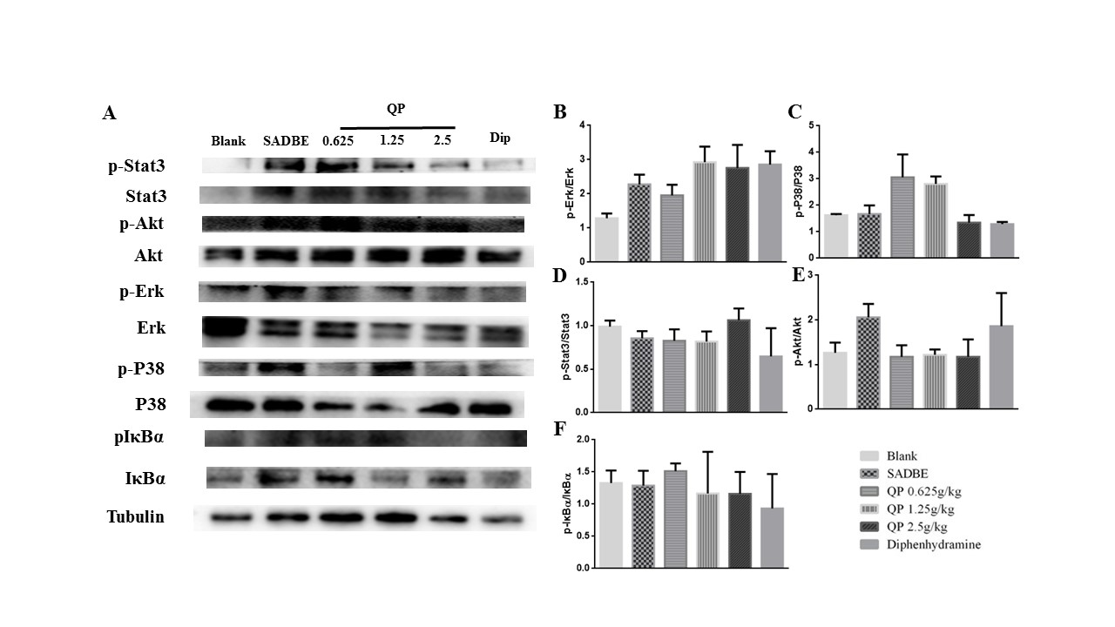
Figure S2∣QP suppressed the phosphorylation of MAPKs in the DRG of SADBE mice. Expression of p-Erk, p-P38, p-Stat3, p-Akt, and p-IκBα in the DRG of SADBE mice was not significantly reduced QP compared to that in the model group (p > 0.05). Data was expressed as mean ± SEM. ANOVA (n=3 each group).

p-Stat3
Blank
SADBE
0.625
1.25
2.5
Dip
QP
Blank
SADBE
0.625
1.25
2.5
Dip
QP
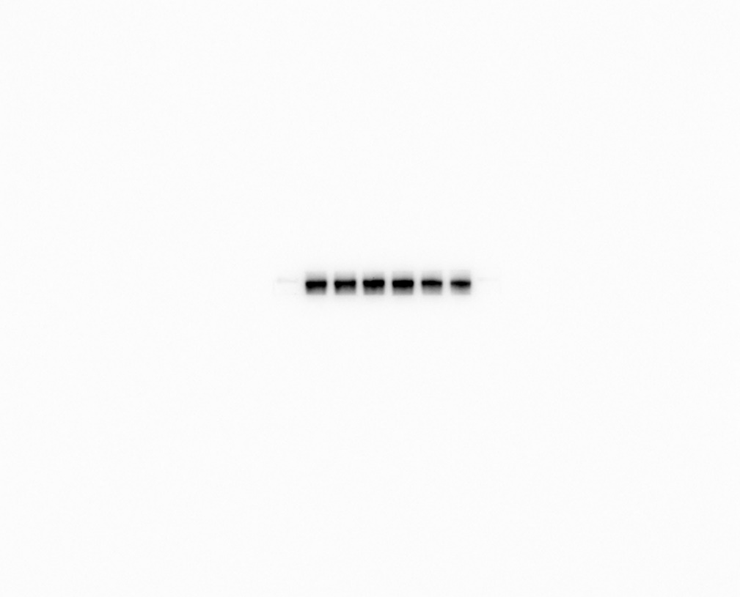
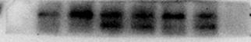
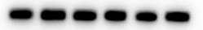
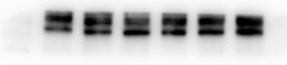
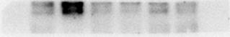
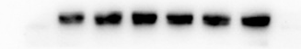
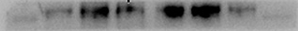
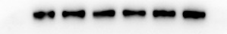
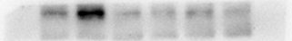
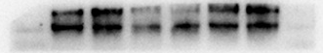

Blank
SADBE
0.625
1.25
2.5
Dip
QP
Tubulin
Blank
SADBE
0.625
1.25
2.5
Dip
QP
Blank
SADBE
0.625
1.25
2.5
Dip
QP
Blank
SADBE
0.625
1.25
2.5
Dip
QP
IκBα
P38
p-IκBα
Blank
SADBE
0.625
1.25
2.5
Dip
QP
Blank
SADBE
0.625
1.25
2.5
Dip
QP
p-Erk
Blank
SADBE
0.625
1.25
2.5
Dip
QP
Akt
Blank
SADBE
0.625
1.25
2.5
Dip
QP
p-Akt
Blank
SADBE
0.625
1.25
2.5
Dip
QP
Stat3
p-P38

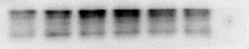

Erk

Figure S3∣The original western blot images of Figure 6A in the manuscript.

Blank
SADBE
0.625
1.25
2.5
Dip
QP
Blank
SADBE
0.625
1.25
2.5
Dip
QP
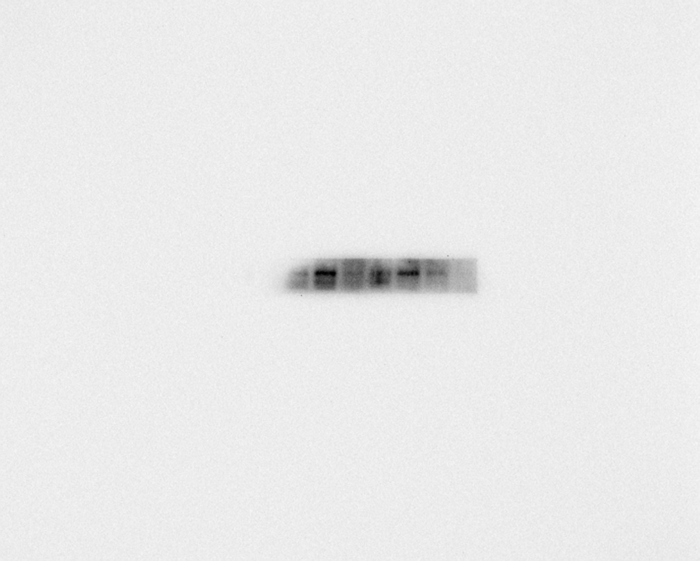

p-IκBα
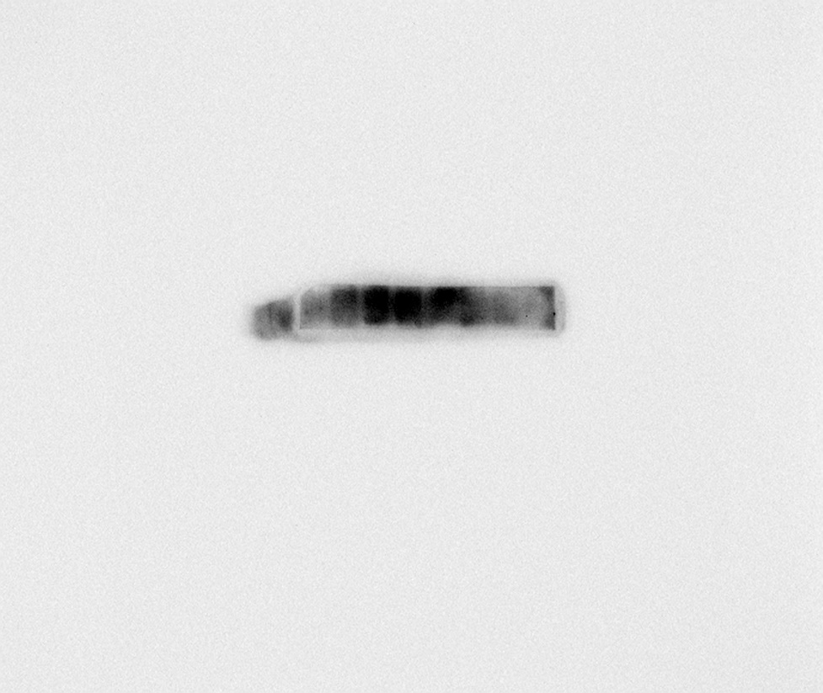
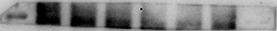
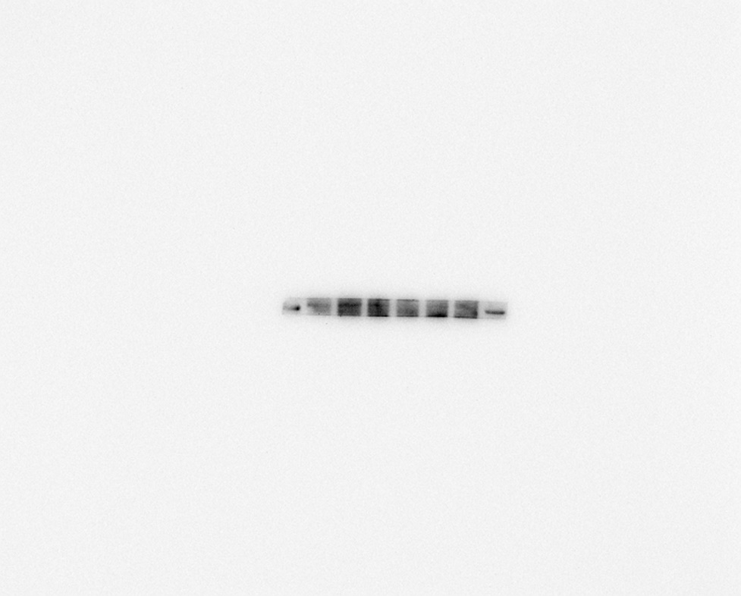

p-Akt

Blank
SADBE
0.625
1.25
2.5
Dip
QP
p-Erk

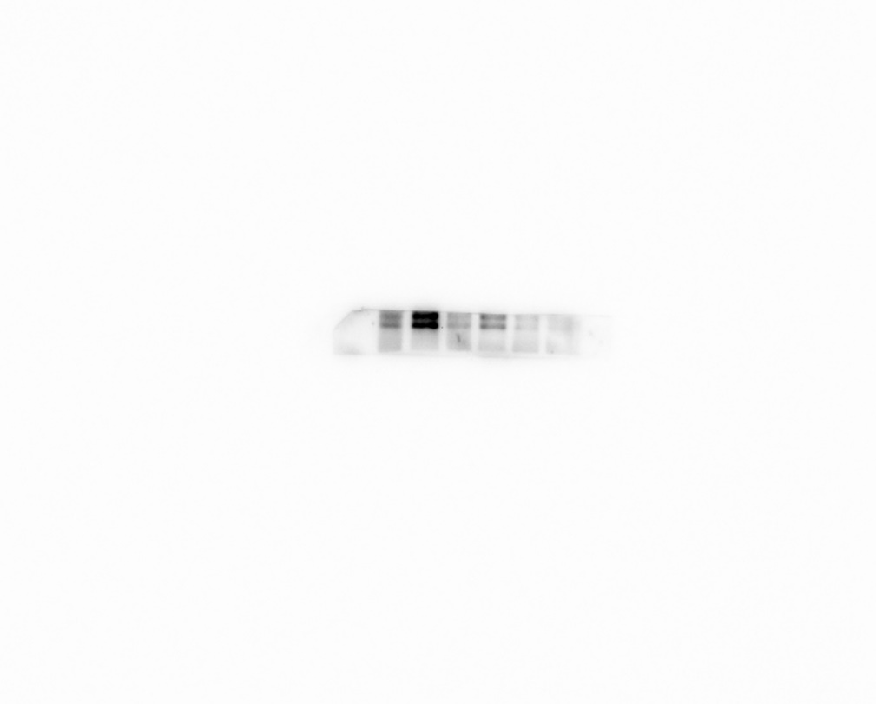

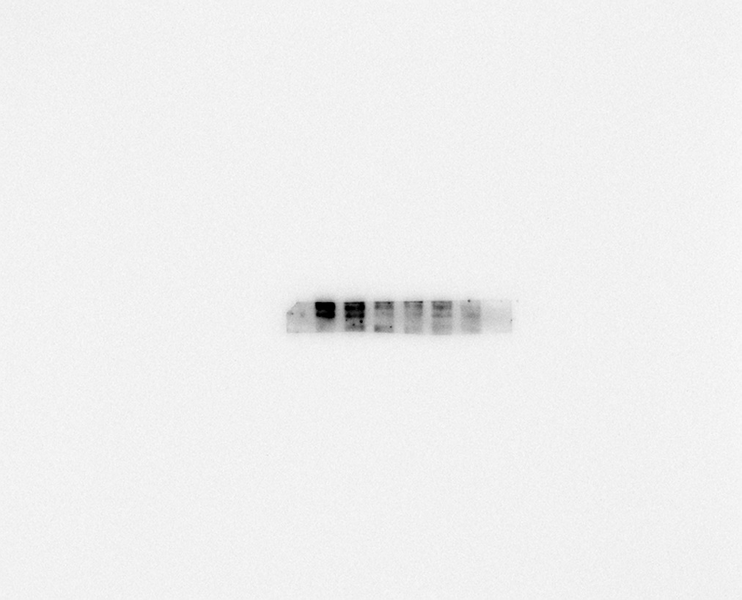

Figure S4∣The original western blot images of p-Akt, p-IκBα and p-Erk.

Blank
SADBE
0.625
1.25
2.5
Dip
QP
Blank
SADBE
0.625
1.25
2.5
Dip
QP
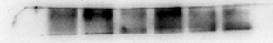
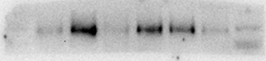
p-Stat3
p-P38
Blank
SADBE
0.625
1.25
2.5
Dip
QP
Blank
SADBE
0.625
1.25
2.5
Dip
QP

Stat3
Blank
SADBE
0.625
1.25
2.5
Dip
QP
P38
p-Akt
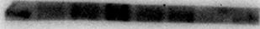
Blank
SADBE
0.625
1.25
2.5
Dip
QP
Blank
SADBE
0.625
1.25
2.5
Dip
QP
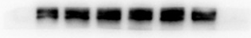
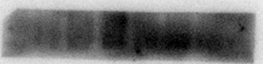
Akt
p-IκBα

Blank
SADBE
0.625
1.25
2.5
Dip
QP
Blank
SADBE
0.625
1.25
2.5
Dip
QP
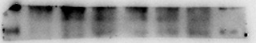
p-Erk
IκBα
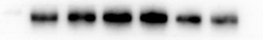
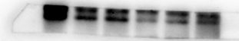
Figure S5∣The original western blot images of Figure S2 in the manuscript.
Blank
SADBE
0.625
1.25
2.5
Dip
QP
Blank
SADBE
0.625
1.25
2.5
Dip
QP
Tubulin
Erk

