Supplementary data

Decreased ATP synthesis and lower pH may lead to abnormal muscle contraction and skin sensitivity in human skin

Eun Ju Kim, Dong Hun Lee , Yeon Kyung Kim, Min-Kyoung Kim, Jung Yun Kim, Min Jung Lee, Won Woo Choi, Hee Chul Eun, and Jin Ho Chung

Supplementary Table 1. Up-regulated genes in human sensitive skin.

Gene title | Gene symbol | Entrez gene ID | S/NS(-) | S/NS(+)
Immune response
Immunoglobulin light chain variable region complementarity determining region (CDR3) mRNA | --- | --- | 2.11 | 6.60
Major histocompatibility complex, class I, C | HLA-C | 3107 | 1.65 | 3.86
Immunoglobulin heavy constant alpha 1 ///  immunoglobulin heavy constant alpha 2 (A2m marker) | IGHA1 /// IGHA2 | 3493 ///  3494 | 1.89 | 2.79
Cadherin 1, type 1, E-cadherin (epithelial) | CDH1 | 999 | 1.90 | 2.23
Inflammation response
S100 calcium binding protein A8 | S100A8 | 6279 | 1.49 | 2.63
Others
Transferrin receptor (p90, CD71) | TFRC | 7037 | 1.32 | 2.65
Serpin peptidase inhibitor, clade B (ovalbumin), member 13 | SERPINB13 | 5275 | 1.28 | 2.38
ARP2 actin-related protein 2 homolog (yeast) | ACTR2 | 10097 | 1.55 | 2.19
Tumor necrosis factor receptor superfamily, member 19 | TNFRSF19 | 55504 | 1.40 | 2.07
GM2 ganglioside activator | GM2A | 2760 | 1.68 | 2.06
Tyrosine 3-monooxygenase/tryptophan 5-monooxygenase activation protein, zeta | YWHAZ | 7534 | 1.31 | 2.01
FK506 binding protein 5 | FKBP5 | 2289 | 1.37 | 2.01
Peptidase inhibitor 3, skin-derived (SKALP) | PI3 | 5266 | 2.11 | 1.97
HORMA domain containing 1 | HORMAD1 | 84072 | 2.25 | 1.88
Ets homologous factor | EHF | 26298 | 1.21 | 2.37
Transcription elongation factor A (SII), 1 | TCEA1 | 6917 | 1.88 | 2.84
Tumor protein p63 | TP63 | 8626 | 1.63 | 2.29
S : Sensitive skin, NS : Non-sensitive skin, (-): normal saline application, (+): lactic acid application.

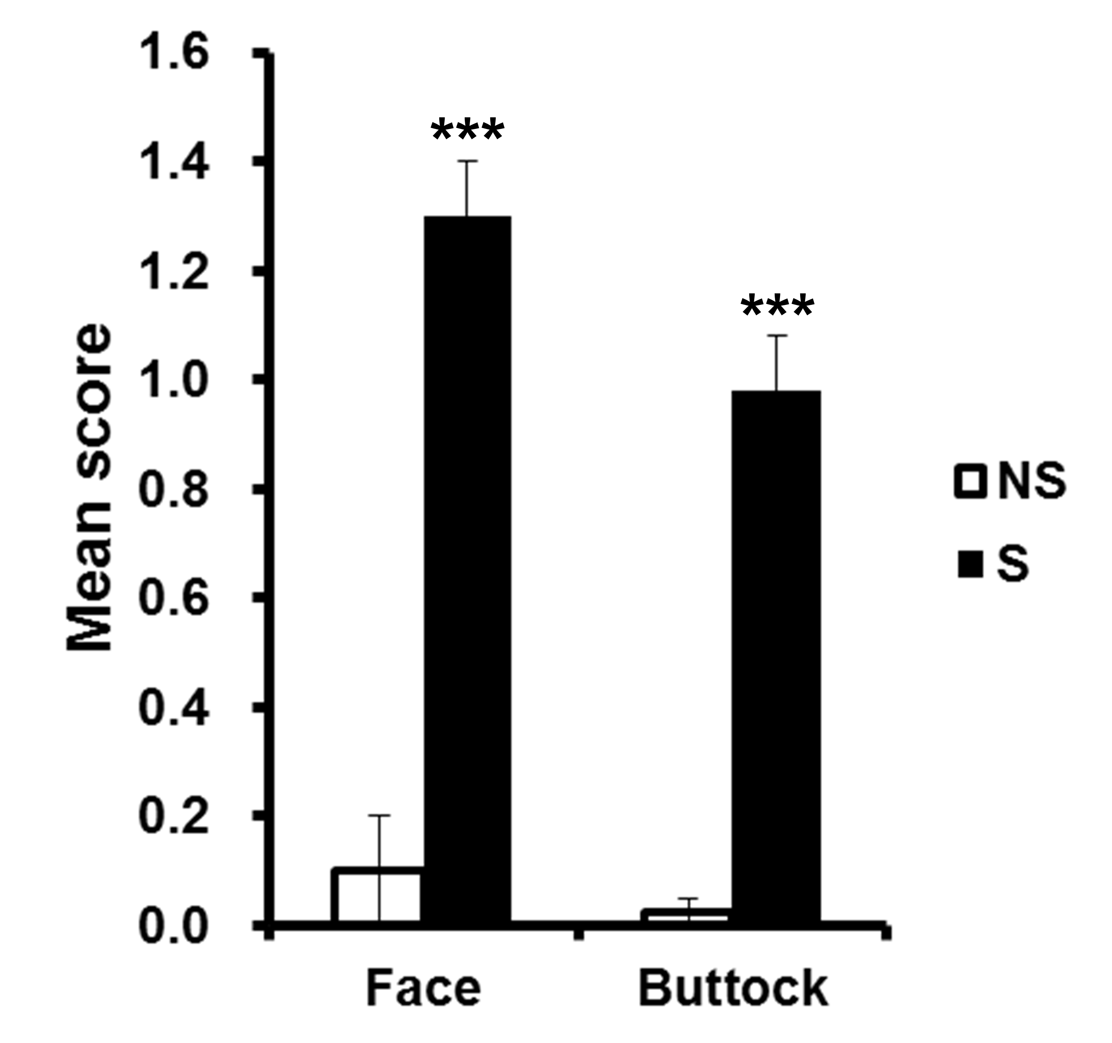

Supplementary Fig. 1.
The lactic acid sting test score. Sensitive skin individuals were identified based on self-assessment questionnaires and 10% lactic acid stinging test. The stinging sensation was rated by volunteers at every 1 minute for 10 minutes on a 4-point scale with cumulative stinging scores (0 = none, 1 = slight, 2 = moderate, and 3 = severe). Subjects showing positivity to the lactic acid sting test with conforming replies from the questionnaires were classified as having sensitive skin (S), while those showing negative lactic acid sting test results with incompatible questionnaire responses were classified as having non-sensitive skin (NS). (n = 5); ***P < 0.001, the NS group vs. the S group.

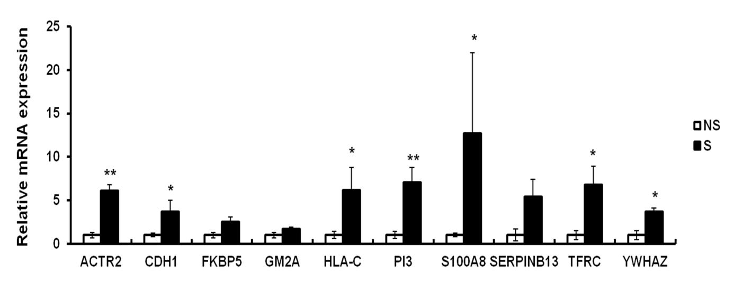

Supplementary Fig. 2.
Verification of up-regulated genes expression in sensitive human skin tissues. Sensitive skin individuals were identified based on self-assessment questionnaires and 10% lactic acid stinging test. Sensitive (S) human skin samples and non-sensitive (NS) human skin samples were obtained from facial malar prominence by a punch biopsy. Each transcript level was measured by real-time PCR. Data represent mean ± SEM of the ratio between each gene and 36B4. (n = 5); *P < 0.05, **P < 0.01.

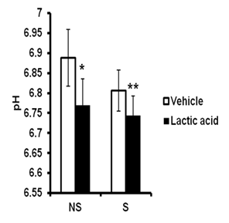

Supplementary Fig. 3.
The tissue pH. Skin tissue samples were homogenized in HBSS buffer and pH was measured with a pH meter (Waterproof pH Spear, Eutech Instruments Pte Ltd, Singapore). All data represent mean ± SEM. NS : non-sensitive, S: sensitive. (n = 5); *P < 0.05, **P < 0.01 vs the NS vehicle group.

