Supplemental Materials
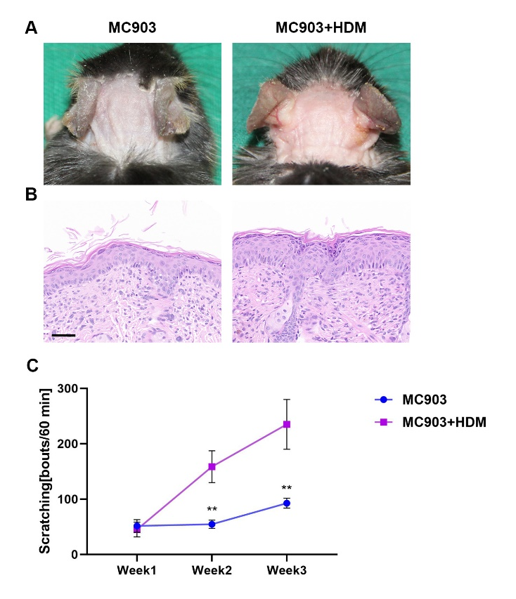
Figure S1. MC903+HDM treated mice exhibit severer AD symptoms compared to MC903 treated mice. (A) Skin appearance showed that MC903+HDM mice displayed more serious erythema, edema, and excoriation than MC903 mice. (B) H&E staining of skin sections showed that severer hyperkeratosis and inflammatory cell infiltration were found in MC903+HDM mice. Bar=50μm. (C) MC903+HDM mice had more scratching bouts in 60 minutes than MC903 mice. Unpaired t tests, **P < 0.01.

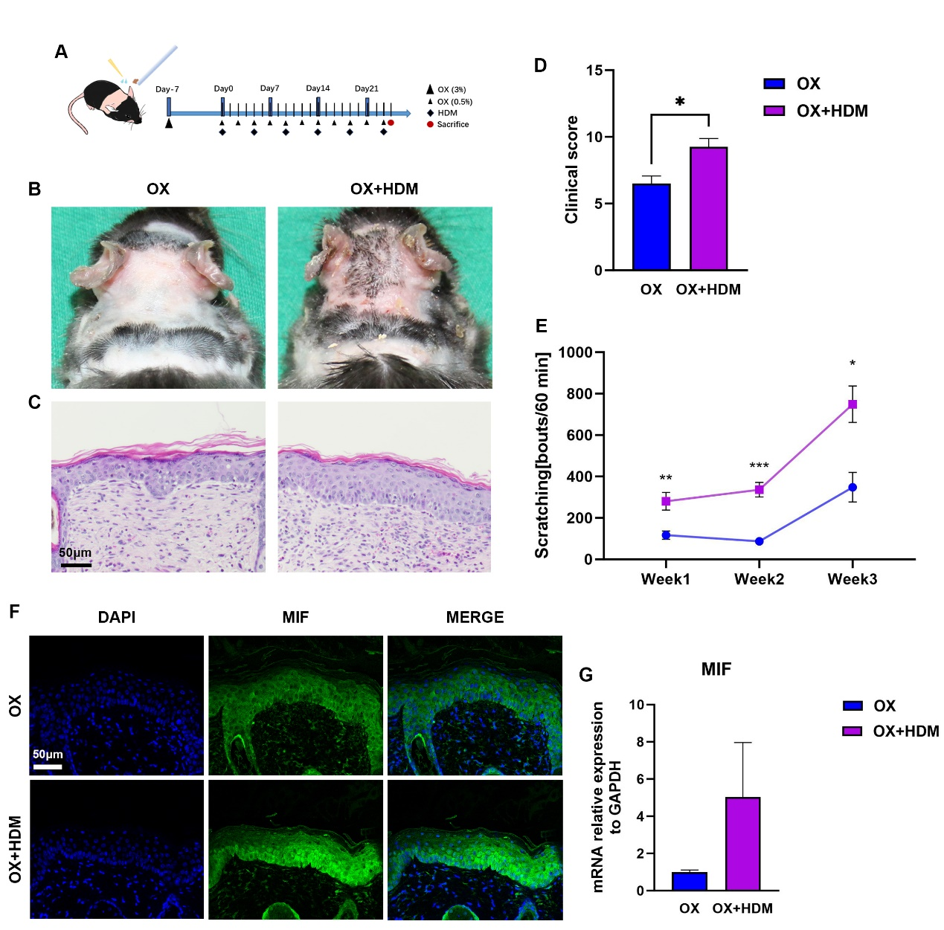
Figure S2. MIF expression is upregulated in the OX+HDM treated AD model compared to OX treated mice. ((A) Mice neck skin (2.5cm*2.5cm) was topically applied once with oxazolone (3% in 4 acetone: 1olive oil). After 7 days, 0.5% oxazolone was topically applied every other day for three weeks. HDM ointment was applied twice per week for 6 times. (B) Skin appearance showed that OX+HDM mice displayed more serious erythema, excoriation and desquamation than OX mice. (C) H&E staining of skin sections showed that severer hyperkeratosis and inflammatory cell infiltration were found in OX+HDM mice. Bar=50μm. (D) Higher clinical score (redness, bleeding, eruption and scaling scored 0-3 each) was found in OX+HDM mice than in OX mice. Unpaired t tests, *P < 0.05. (E) More scratching bouts in 60 minutes were found in OX+HDM mice than in OX mice. Unpaired t tests, *P < 0.05, **P < 0.01, ***P < 0.001. (F) Representative immunofluorescence images of MIF in skins showed that OX+HDM mice expressed more MIF than OX mice. Bar=50μm. (G) MIF mRNA expression in skin was higher in OX+HDM treated mice than in OX treated mice.
OX, oxazolone.

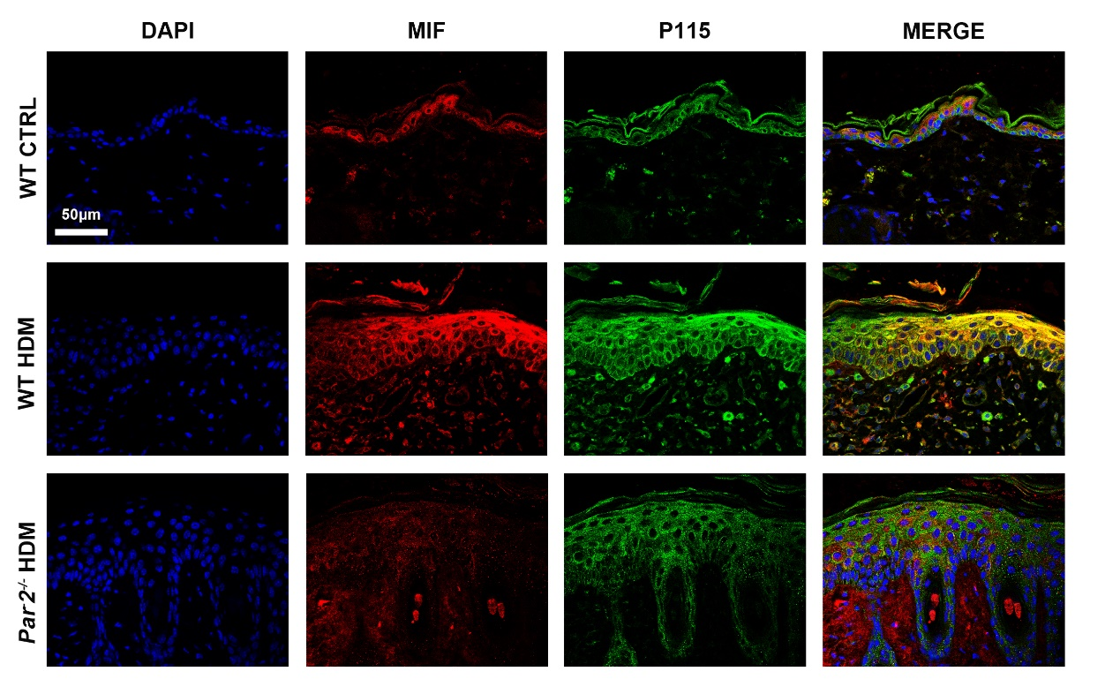
Figure S3. Representative images of MIF and P115 expression in the skin of AD mice and control group. Stronger MIF and P115 expressions and co-localization in skin were found in HDM-WT mice than in HDM-Par2^{-/-} mice. Bar=50μm. WT, wild type. CTRL, control.

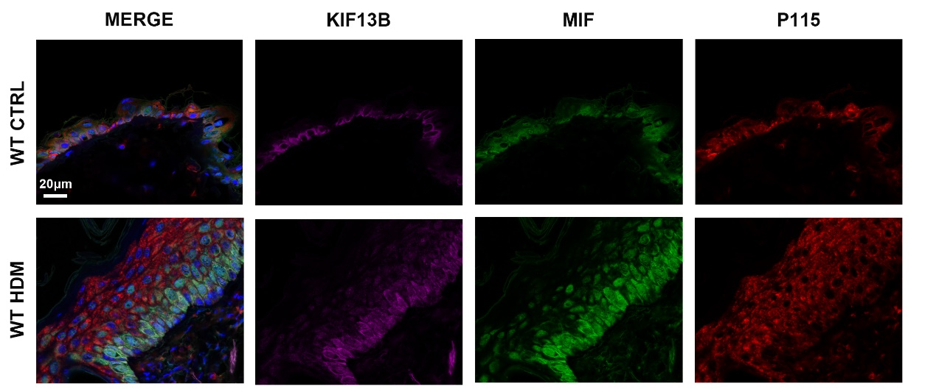
Figure S4. Representative images of of KIF13B, MIF and P115 expression in the skin of AD mice and control group. Stronger MIF expression and co-localization of KIF13B, MIF and P115 in skin were found in HDM-WT mice than in control group. . Bar=20μm.WT, wild type. CTRL, control.

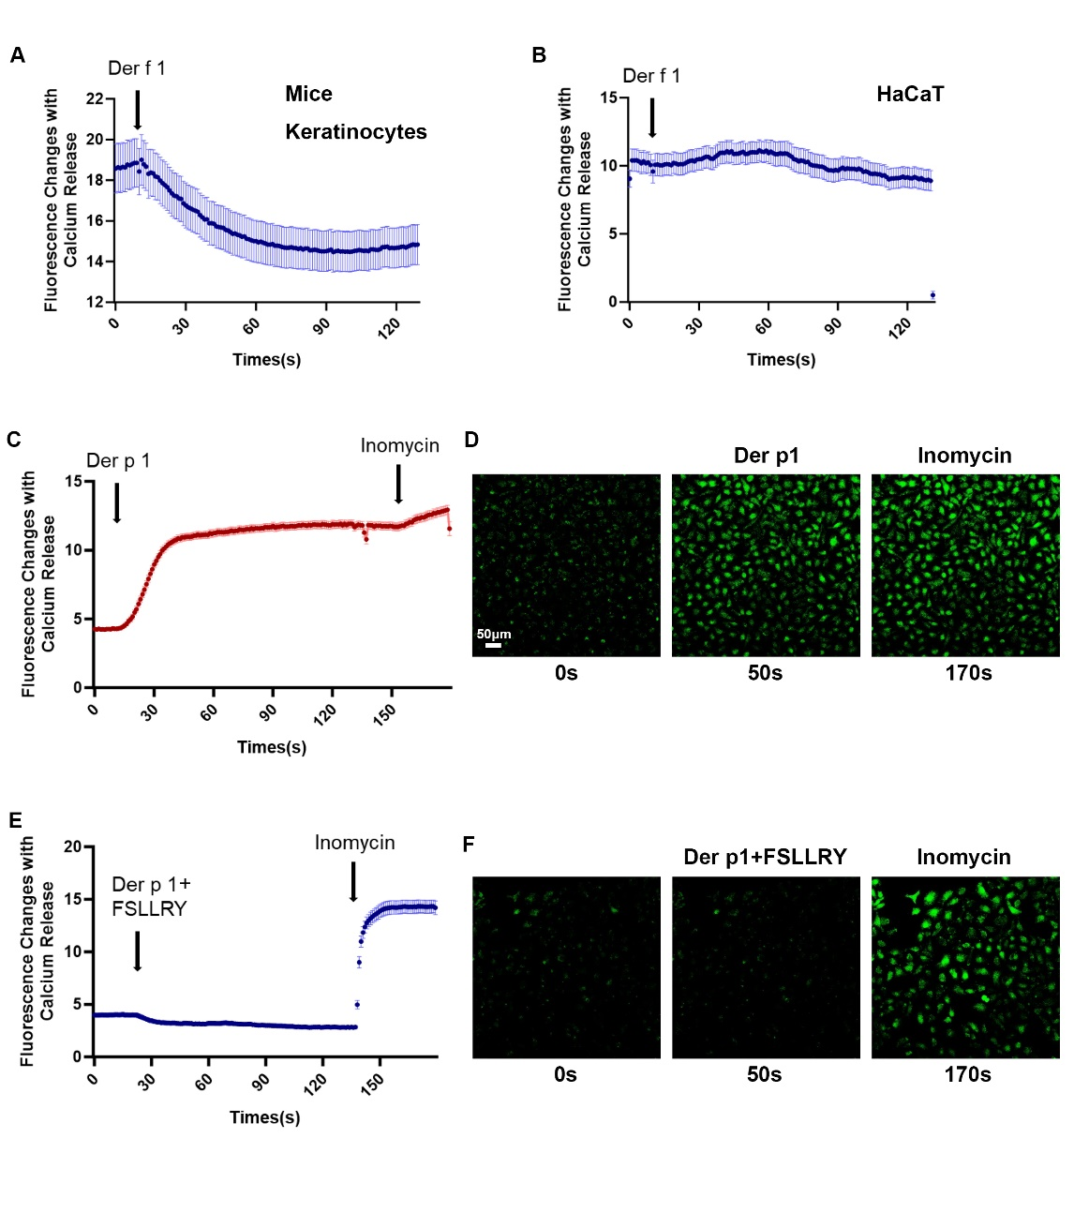
Figure S5. Neither mice keratinocytes nor HaCaT cells exhibit Ca²⁺ mobilization in response to Der f1. In contrast, Der p1 successfully triggers Ca²⁺ mobilization in HaCaT cells, which can be inhibited by the PAR2 antagonist FSLLRY. (A) Representative traces showed that there were no intracellular Ca²⁺ responses elicited by Der f1 (20μg/μl) in mouse keratinocytes. (B) Representative traces showed that there were no intracellular Ca²⁺ responses elicited by Der f1 (20μg/μl) in HaCaT cells. (C) Representative traces showed that Ca²⁺ mobilization was elicited by Der p1 (25μg/μl) in HaCaT cells. Inomycin served as a positive control. (D) Representative fluorescence images of Fluo 4 (5 μM) loaded HaCaT cells showed the Ca²⁺ responses stimulated by Der p1 at 0s, 50s and 170s. Bar=50μm. (E) Representative traces showed that the Ca²⁺ mobilization induced by Der p1 (25μg/μl) in HaCaT cells was inhibited by pretreatment of FSLLRY (100μM). Inomycin served as a positive control. (F) Representative fluorescence images of Fluo 4 (5 μM) loaded HaCaT cells showed that the Ca²⁺ responses induced by Der p1 was inhibited by Der p1+FSLLRY treatment at 0s, 50s and 170s. N = 3 mice per group.

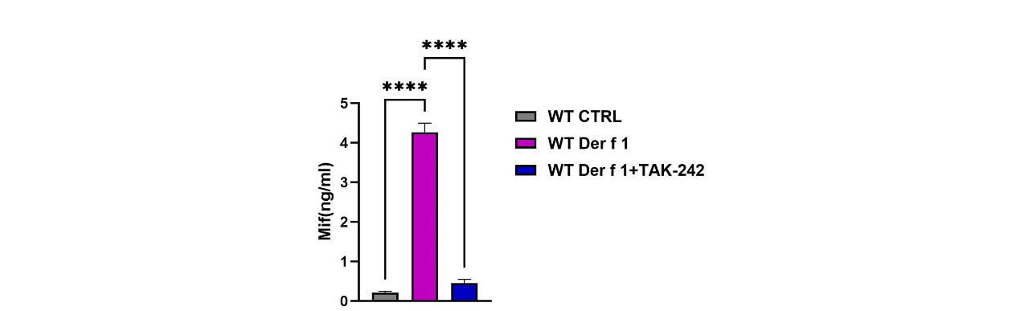
Figure S6. MIF release in the supernatant of mouse primary keratinocytes treated with Der f1 or the TLR4 antagonist TAK-242. ELISA of MIF showed that mouse primary keratinocytes (1.5*10⁵ cells) treated with Der f1 (10μg/μl)+TAK-242 (10μM) for 12 hours inhibited the MIF release induced by Der f1 stimulation. (1.5 × 10⁵ cells per group). One-way ANOVA. ****p < 0.0001. WT, wild type.

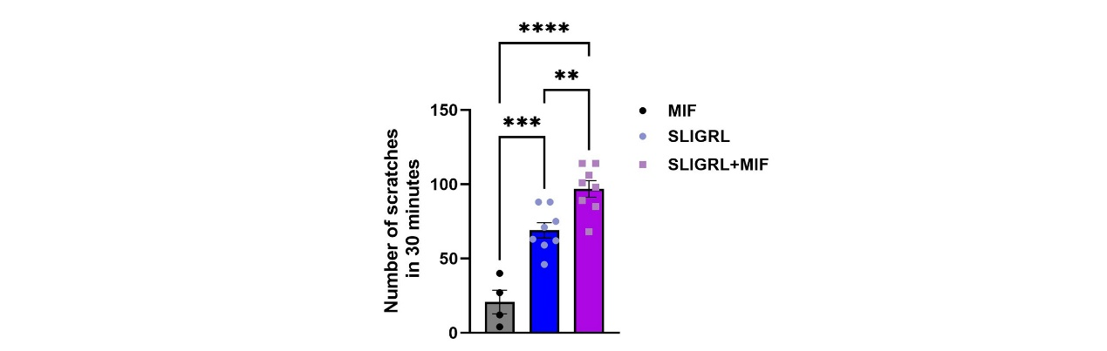
Figure S7. MIF synergized with PAR2 agonist SLIGRL to promote mice acute itch. Mice scratching bouts increased obviously induced by intradermal injection of SLIGRL (50μg) +MIF (0.5μg) than injecting SLIGRL only group. One-way ANOVA, n=4-8, ** p < 0.01, *** p < 0.001, ****p < 0.0001.

Table S1. Primers for quantitative PCR.
mMif  Gene ID:17319 | Up | 5′-TTAGCGGCACGAACGATCC -3′
mMif  Gene ID:17319 | Down | 5′-ACAGCAGCTTACTGTAGTTGC -3′
mKif13b  Gene ID:16554 | Up | 5′-GCTCTGTAGTGGACTCTTTGAAC -3’
mKif13b  Gene ID:16554 | Down | 5′-TTTGGGGTCAAGAAGGTCTCG -3’
mIL-4  Gene ID:16189 | Up | 5′-GGTCTCAACCCCCAGCTAGT -3’
mIL-4  Gene ID:16189 | Down | 5′-GCCGATGATCTCTCTCAAGTGAT -3’
mIL-13  Gene ID:16163 | Up | 5′-CCTGGCTCTTGCTTGCCTT -3’
mIL-13  Gene ID:16163 | Down | 5′-GGTCTTGTGTGATGTTGCTCA -3’
mTslp  Gene ID:53603 | Up | 5′-ACGGATGGGGCTAACTTACAA -3’
mTslp  Gene ID:53603 | Down | 5′-AGTCCTCGATTTGCTCGAACT -3’
mArg1  Gene ID:11846 | Up | 5′-CTCCAAGCCAAAGTCCTTAGAG-3’
mArg1  Gene ID:11846 | Down | 5′-AGGAGCTGTCATTAGGGACATC-3’
mIl1b  Gene ID:16176 | Up | 5′-TTCAGGCAGGCAGTATCACTC-3’
mIl1b  Gene ID:16176 | Down | 5′-GAAGGTCCACGGGAAAGACAC-3’
mIl6  Gene ID:16193 | Up | 5′-TAGTCCTTCCTACCCCAATTTCC-3’
mIl6  Gene ID:16193 | Down | 5′-TTGGTCCTTAGCCACTCCTTC-3’
mIl10  Gene ID:16153 | Up | 5′-CTTACTGACTGGCATGAGGATCA-3’
mIl10  Gene ID:16153 | Down | 5′-GCAGCTCTAGGAGCATGTGG-3’
mGapdh  Gene ID:14433 | Up | 5′- AGGTCGGTGTGAACGGATTTG -3′
mGapdh  Gene ID:14433 | Down | 5′- TGTAGACCATGTAGTTGAGGTCA -3′

Table S2. KC_cluster identity
Cell type | Genes
Undifferentiated KC | KRT5, KRT14, CCL27A, CXCL14, KRT15
Basal_1 | TSLP, IGFBP3
Basal_2 | COL23A1, FST
Basal_3 | IL31RA, POSTN
Differentiated KC | KRT1, KRT10, KRTDAP
Spinous_1 | S100A9, S100A8
Spinous_2 | SKINT6, KRT6A
Inner root sheath cell | KRT71, KRT73, TCHH
Proliferating KC | MKI67, TOP2A, HIST1H2AP, HIST1H2AE
KC：Keratinocytes.

