Supplemental material

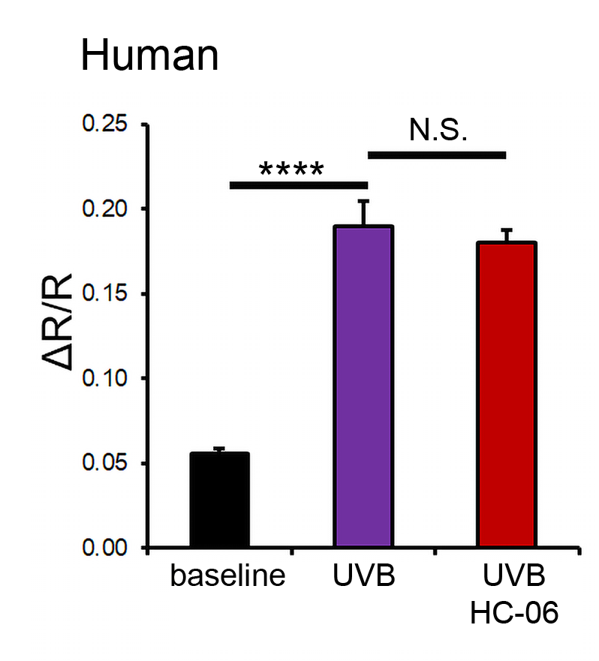
Supplementary Figure 1. UVB stimulus induces Ca²⁺ elevations in debrided human CEs (N = 3). UVB-evoked responses are unaffected by the TRPV4 antagonist HC-06. **** P < 0.001

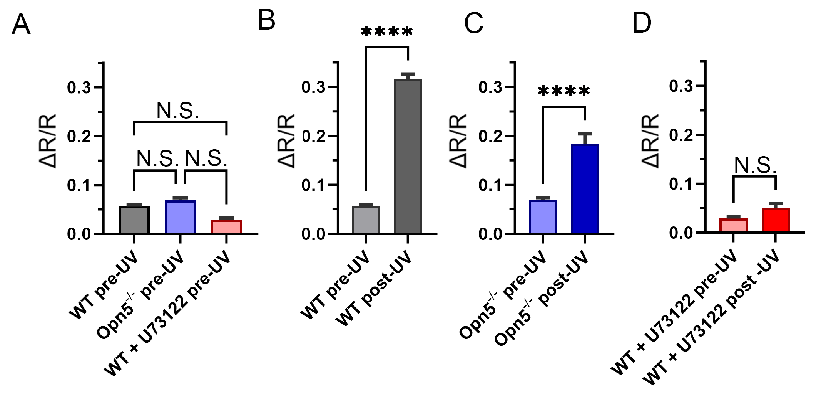 Supplementary Figure 2. Dissociated cells. Calcium responses in WT, Opn5^{-/-} and U73122-treated cells before and following UVB stimulation. (A) PLC and OPN5 do not contribute to calcium homeostasis in unstimulated cells. OPN deletion and PLC inhibition did not induce significant [Ca²⁺]_{i} lowering. (B & C) Fluorescence levels in WT and Opn5^{-/-} CECs show UVB-induced [Ca²⁺]_{i} elevations which are lower in neuropsin-lacking cells. (D) PLC inhibition with U73122 was associated with significant inhibition of UVB-evoked signals.

Supplementary Table 1: Relative release of 96 proteins following UVB and GSK101 stimulation (control = 1.00). Proteins with >50% increase following 3 min exposure to UVB are marked by red fields. Proteins with >50 release increase following 3 min stimulation with GSK101 (25 nM) labeled with yellow fields; the specificity of the effect was validated with the TRPV4 inhibitor HC-06 (1 μM). Proteins with >50% increase following exposure to UVB and GSK101 are shown in orange fields. N = 2 independent experiments, n = 2 dot assays/experiment. Average change ± S.E.M.
Protein | GSK101 | GSK101+HC-06 + GSK101 | UVB
Axl | 1.35±0.36 | 0.73±0.13 | 1.35±0.41
BLC | 1.02±0.21 | 0.63±0.12 | 0.94±0.17
CD30L | 1.28±0.17 | 0.68±0.16 | 0.96±0.19
CD30/TNFRSF8 | 2.28±1.33 | 0.57±0.09 | 1.94±0.56
CD40 | 2.39±1.10 | 0.52±0.15 | 5.52±1.00
CRG-2  CTACK | 1.61±0.09 | 0.71±0.06 | 0.89±0.38
CTACK | 1.01±0.06 | 0.85±0.02 | 1.27±0.18
CXCL16 | 1.31±0.05 | 0.53±0.04 | 0.49±0.13
eotaxin | 1.51±0.39 | 0.73±0.23
eotaxin-2 | 1.14±0.25 | 0.39±0.01 | 0.52±0.05
FAS ligand | 0.90±0.20 | 0.38±0.06 | 0.72±0.09
fractalkin | 0.60±0.03 | 0.23±0.05 | 0.26±0.02
G-CSF | 1.01±0.06 | 0.67±0.11 | 0.55±0.09
GM-CSF | 0.93±0.09 | 0.43±0.08 | 0.41±0.03
IFNγ | 1.17±0.40 | 0.55±0.10 | 1.13±0.25
IGF-BP-3 | 0.96±0.02 | 0.87±0.03 | 1.59±0.02
IGF-BP-5 | 1.98±0.77 | 0.67±0.12 | 1.96±0.45
IGF-BP-6 | 1.14±0.06 | 0.50±0.08 | 0.65±0.11
IL-1α | 1.09±0.03 | 0.77±0.05 | 1.37±0.14
IL-2β | 2.52±0.57 | 0.61±0.11 | 2.16±0.13
IL-2 | 1.68±0.06 | 0.82±0.15 | 0.98±0.21
IL-3 | 1.71±0.16 | 0.83±0.09 | 1.10±0.04
IL-3 Rβ | 1.34±0.09 | 0.65±0.09 | 0.46±0.05
IL-4 | 0.72±0.08 | 0.22±0.03 | 0.82±0.24
IL-5 | 0.79±0.20 | 0.42±0.12 | 1.07±0.03
IL-6 | 0.57±0.12 | 0.32±0.05 | 0.81±0.15
IL-9 | 0.60±0.09 | 0.33±0.10 | 0.43±0.04
IL-10 | 0.96±0.22 | 0.42±0.08 | 0.79±0.21
IL-12-p40/p70 | 0.82±0.18 | 0.39±0.06 | 0.88±0.12
IL-12-p70 | 0.86±0.06 | 0.75±0.08 | 1.51±0.04
IL-13 | 0.97±0.17 | 0.50±0.11 | 0.93±0.06
IL-17 | 1.60±0.40 | 0.57±0.04 | 1.41±0.11
KC | 1.16±0.23 | 0.44±0.06 | 0.59±0.10
Leptin R | 1.49±0.11 | 0.73±0.11 | 0.83±0.07
Leptin | 1.91±0.18 | 0.91±0.27 | 5.83±1.21
LIX | 1.01±0.01 | 0.86±0.04 | 1.46±0.03
L-selectin | 1.55±0.27 | 0.63±0.13 | 1.04±0.18
lymphotactin | 0.67±0.25 | 0.18±0.04 | 1.04±0.32
MCP-1 | 0.78±0.09 | 0.41±0.06 | 1.18±0.18
MCP-5 | 0.72±0.09 | 0.26±0.01 | 0.56±0.11
M-CSF | 0.88±0.03 | 0.75±0.03 | 1.40±0.06
MIG | 0.79±0.25 | 1.04±0.41 | 2.78±0.57
MIP-1α | 1.02±0.05 | 0.52±0.07 | 1.02±0.21
MIP-1γ | 1.11±0.07 | 0.63±0.15 | 1.09±0.09
MIP-2 | 0.97±0.04 | 0.95±0.08 | 2.01±0.07
MIP-3β | 1.10±0.05 | 0.58±0.13 | 1.10±0.11
MIP-3α | 1.28±0.19 | 0.81±0.13 | 1.62±0.13
PF4 | 1.05±0.01 | 0.96±0.01 | 1.72±0.07
P-selectin | 1.18±0.09 | 1.00±0.07 | 1.75±0.12
RANTES | 1.73±0.18 | 0.73±0.12 | 1.75±0.35
SCF | 1.81±0.17 | 0.51±0.13 | 2.11±0.43
SDF-1α | 0.49±0.16 | 0.11±0.04 | 1.55±0.56
TARC | 0.83±0.20 | 0.17±0.05 | 0.66±0.18
TCA-3 | 0.88±0.02 | 0.57±0.04 | 1.20±0.13
TECK | 0.51±0.06 | 0.13±0.03 | 0.36±0.06
TIMP-1 | 0.49±0.06 | 0.30±0.07 | 1.36±0.12
TNFα | 1.12±0.15 | 0.55±0.07 | 1.11±0.34
sTNF RI | 1.04±0.15 | 0.83±0.06 | 1.52±0.32
sTNF RII | 1.18±0.36 | 0.71±0.28 | 2.10±0.51
TPO | 0.99±0.06 | 0.59±0.18 | 0.75±0.23
VCAM-1 | 0.95±0.09 | 0.39±0.13 | 0.47±0.08
VEGF | 0.96±0.21 | 0.63±0.16 | 2.05±0.32
bFGF | 2.06±0.54 | 0.39±0.04 | 0.44±0.06
DPPIV/CD26 | 2.31±0.03 | ??? | 1.04±0.17
Dtk | 1.52±0.41 | 0.15±0.15 | 1.94±0.31
E-selectin |  |  | 2.34±0.30
Fcg RIIB | 1.61±0.17 | 0.49±0.06 | 0.82±0.07
Flt-3 Ligand | 1.95±0.56 | 0.73±0.19 | 0.69±0.12
GITR | 1.19±0.29 | 0.59±0.11 | 1.12±0.05
HGF R | 1.71±0.12 |  | 1.76±0.22
ICAM-1 | 0.94±0.04 | 0.84±0.03 | 1.48±0.05
IGFBP-2 | 1.10±0.06 | 1.05±0.11 | 1.21±0.01
IGF-I | 1.10±0.13 | 0.66±0.07 | 0.64±0.04
IGF-II | 1.37±0.32 | 0.59±0.02 | 0.75±0.25
IL-15 | 2.10±0.42 |  | 1.44±0.25
IL-17B R | 0.66±0.06 |  | 0.91±0.14
IL-7 | 1.09±0.06 | 0.40±0.08 | 0.86±0.22
I-TAC | 1.33±0.14 | 0.43±0.09 | 0.89±0.21
lungkin | 1.02±0.09 | 0.71±0.06 | 1.14±0.15
MDC | 1.64±0.40 | 0.62±0.25 | 1.74±0.44
MMP-2 | 1.36±0.19 | 0.28±0.03 | 0.58±0.03
MMP-3 | 1.31±0.30 | 0.27±0.27 | 2.83±0.59
osteopontin | 1.25±0.37 | 0.79±0.18 | 2.18±0.47
osteoporotegerin | 1.38±0.14 | 0.86±0.51 | 1.56±0.60
Pro-MMP-9 | 1.11±0.11 | 0.78±0.29 | 2.07±0.19
resistin | 1.84±0.57 | 0.00±0.00 | 2.59±0.66
Shh-N | 1.45±0.26 | 0.00±0.00 | 1.99±0.50
thymus CK-1 | 0.98±0.21 | 0.00±0.00 | 3.38±0.95
TIMP-2 | 1.12±0.15 | 0.68±0.07 | 0.95±0.21
TRANCE | 1.14±0.07 | 0.58±0.07 | 1.08±0.13
TROY | 1.15±0.40 | 0.49±0.20 | 1.93±0.36
TSLP | 3.08±0.81 | 1.15±0.47 | 2.95±0.17
VEGF R1 | 1.63±0.33 | 0.97±0.32 | 1.77±0.36
VEGF R2 | 1.21±0.31 | 0.42±0.25 | 1.28±0.17
VEGF R3 | 1.80±0.86 | 0.46±0.28 | 1.62±0.26
VEGF-D | 1.36±0.34 | 0.43±0.29 | 1.33±0.35

Supplementary Table 2. Primer sequences used for PCR and semiquantitative Real-Time PCR analysis

Gene name | Forward primer | Reverse primer | Product size (bp) | NCBI #
Opn1SW | GGATCAGAATGGCCTCACCT | TTCTTCGTTTCGAGGGGCTC | 250 | NM_007538.3
Opn2 | GTGCCCCAGAGAAACACAGT | AAAGTGACCGTGGGTGGAAA | 136 | NM_145383.2
Opn3 | GCATCTGGCGTCATCGTCTA | ACTCAACACCGCAACGTACT | 167 | NM_010098.4
Opn4 | CATCCCAGTTTCCCCTTGCT | CGCAGAGCTACACAGTCACA | 116 | NM_013887.2
Opn5 | GCTGCATACTGTAACCGCAG | TTTCTCGGCCTCAGAACACA | 161 | NM_181753.4
Gapdh | GGTTGTCTCCTGCGACTTCA | TAGGGCCTCTCTTGCTCAGT | 220 | NM_001289726.2

