Supporting information for
Epidermal PAR2-TRPV3-IL-33 signaling promotes mast cell recruitment and sensory nerve-mast cell interactions in atopic dermatitis

Jiahui Zhao, Lingxuan Zhou, Chenyu Wang, Ziyan Rao, Xiaohui Yuan, Jun Cui, Dongyu Zhao, Ying Sun, Yan Chen, Ruoyu Li, Miao Jing

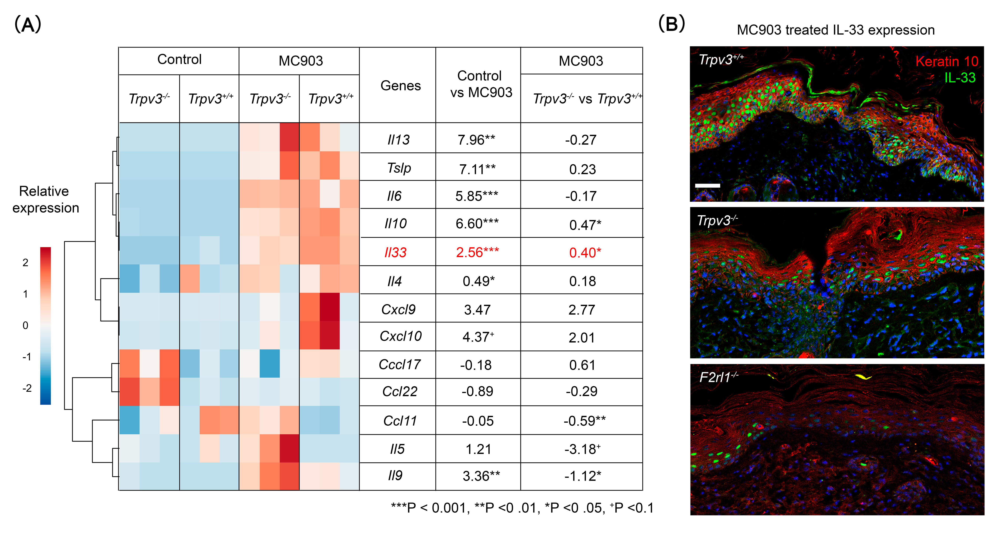
Figure S1. PAR2-TRPV3 signaling induces IL-33 expression in a mouse model of AD.
(A) Heatmap of bulk RNA-sequencing data showing Th2-related gene expression profile in Trpv3^{+/+} and Trpv3^{-/-} mice with or without MC903 treatment. Color intensity represents relative gene expression (z-score normalized per row). Tables show the log₂ fold changes between control and MC903 treatment and between MC903-treated Trpv3^{+/+} and Trpv3^{-/-} mice. (B) Immunofluorescence staining of IL-33 in ear skins from MC903-treated Trpv3^{+/+}, Trpv3^{-/-} and Par2^{-/-} (F2rl1^{-/-}) mice. Scale bar, 50 μm.
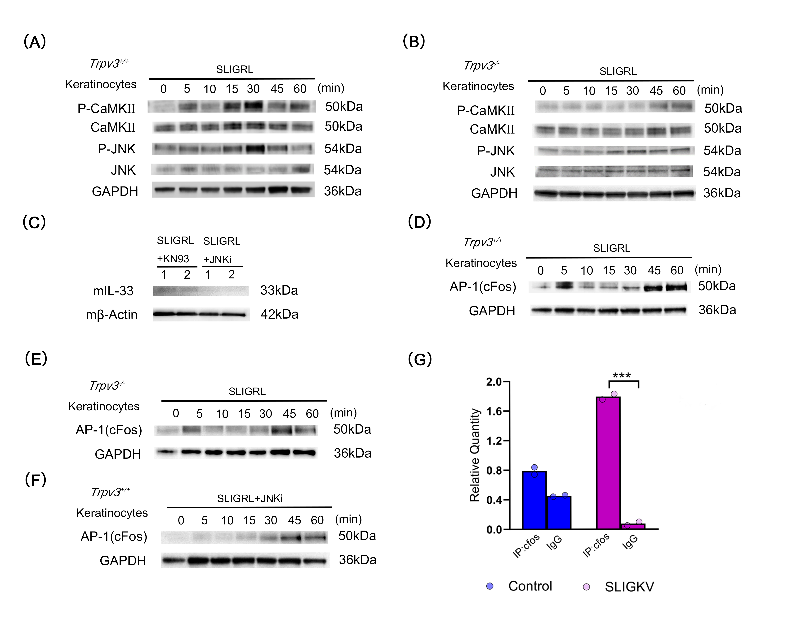
Figure S2. PAR2-TRPV3 signaling axis promotes IL-33 expression in keratinocytes through the CaMKII and JNK phosphorylation pathways.
(A) Time-dependent phosphorylation of CaMKII and JNK in primary mouse keratinocytes stimulated with SLIGRL. (B) Same as (A), except the keratinocytes were derived from Trpv3^{-/-} mice. (C) Expression of IL-33 in mouse keratinocytes stimulated with SLIGRL together with CaMKII inhibitor KN93 or JNK inhibitor SP600125 (JNKi). (D-E) AP-1 changes in WT (D) and Trpv3^{-/-} mouse keratinocytes (E) stimulated with SLIGRL. (F) AP-1 changes in WT mouse keratinocytes stimulated with SLIGRL and JNKi. (G) The binding between c-Fos and IL-33 promoter region in human HaCaT cells with or without SLIGKV stimulation.

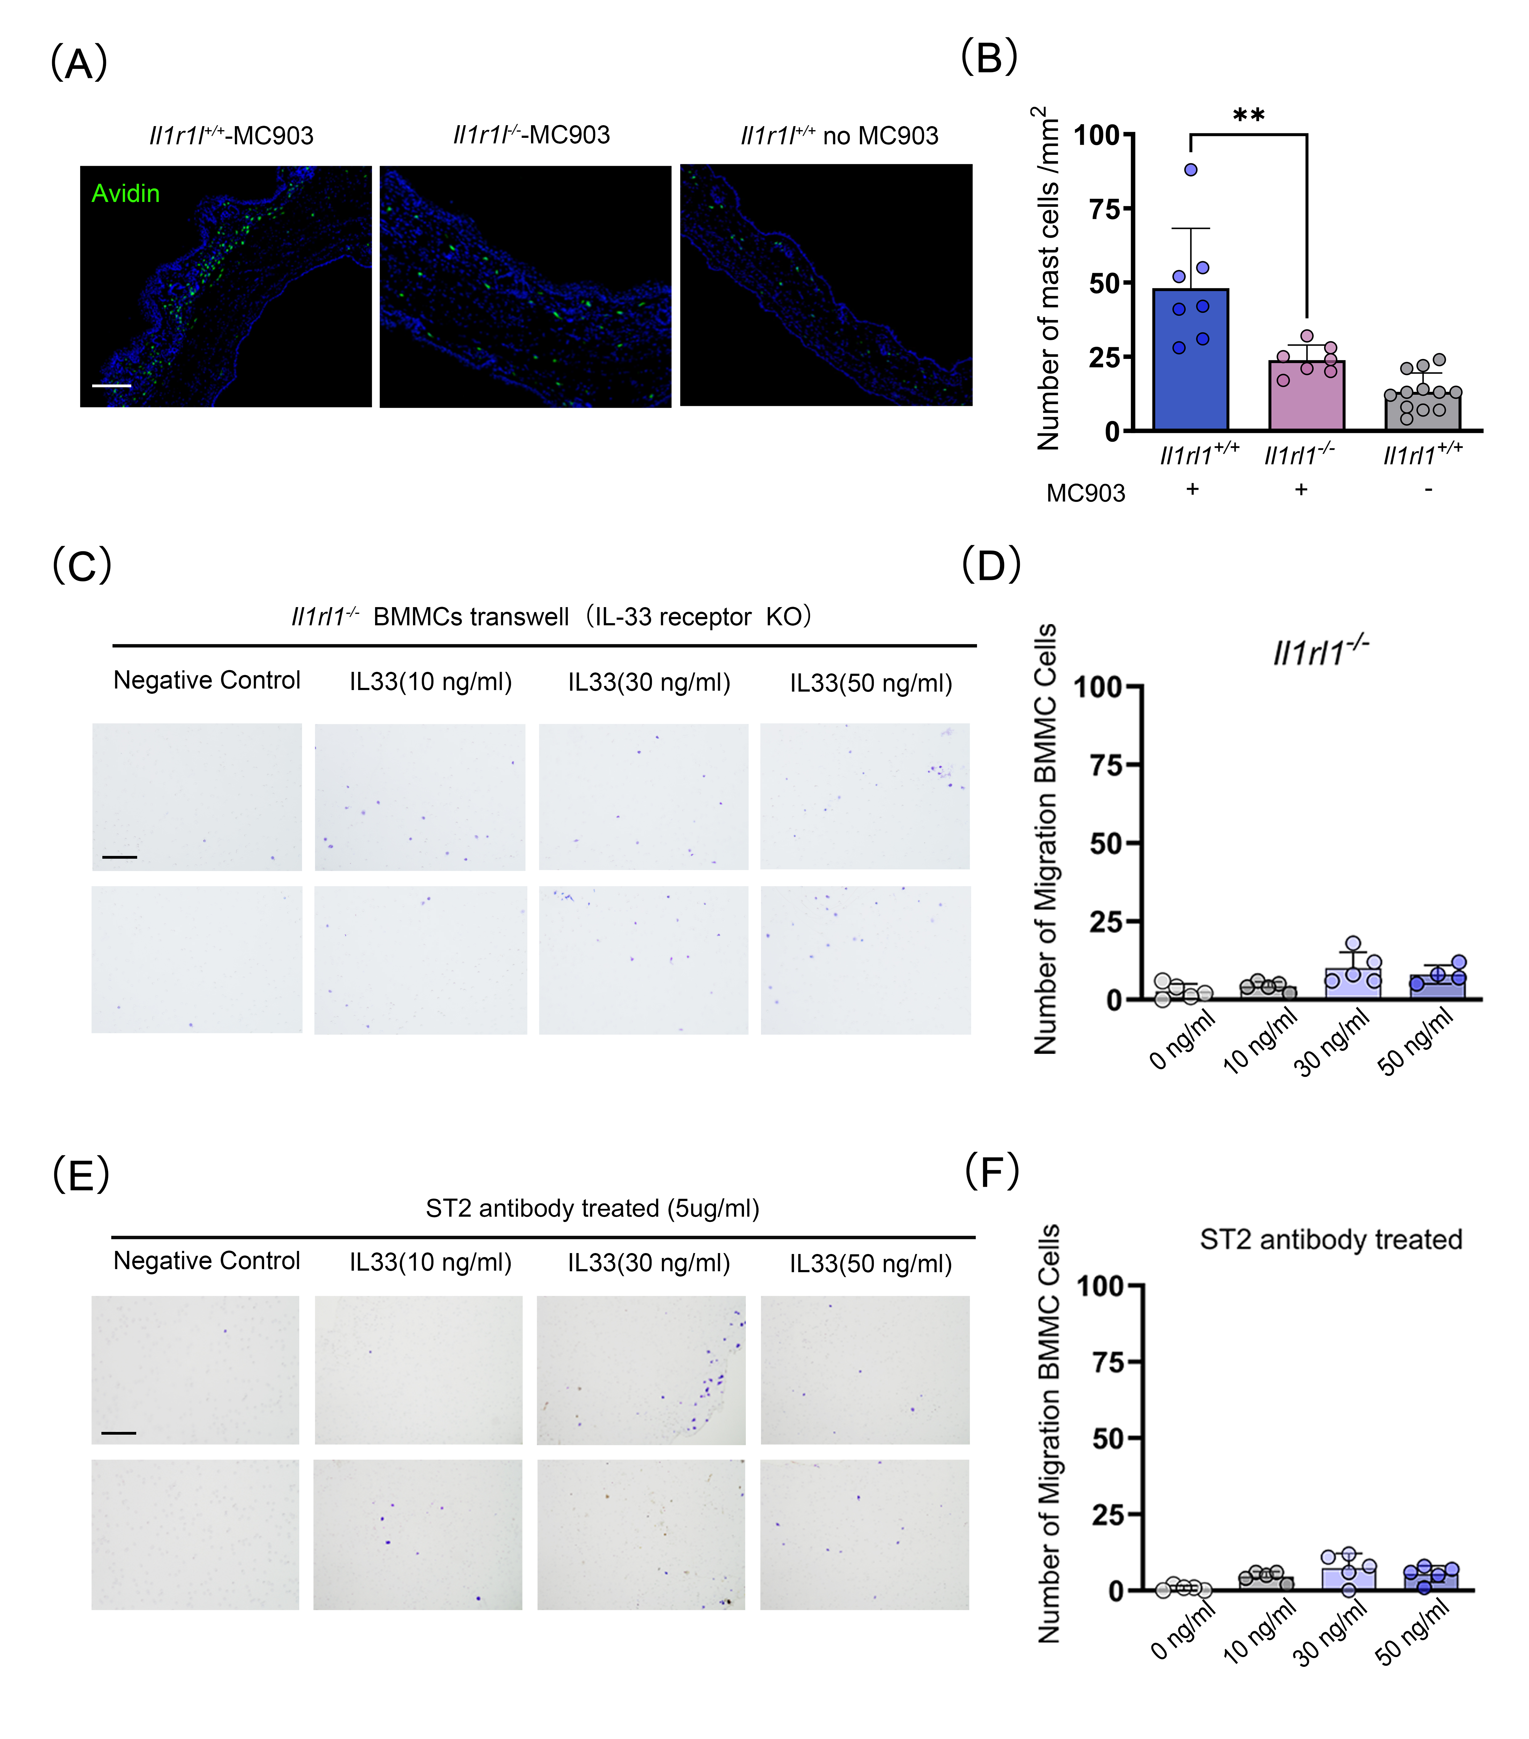
Figure S3. IL-33–ST2 signaling regulates mast cell chemotaxis.
(A) Immunofluorescence staining for mast cells (avidin) in MC903-induced ear skin of Il1rl1⁺/⁺ and Il1rl1⁻/⁻ mice and untreated control mice. Scale bar, 50 μm. (B) Quantification of mast cells (cells/mm²) in ear skin lesions. (C-D) Representative images and quantification of the migrated Il1rl1⁻/⁻ (ST2-deficient) BMMCs towards indicated concentrations of IL-33. Scale bar, 50 μm. (E-F) Similar to (C-D) but the WT BMMCs were pre-treated with ST2 antibody for 30 minutes before transwell test. Scale bar, 50 μm.

Methods
Gene expression data analysis
Calcipotriol-induced AD-like skin lesions were dissected from mice after 7 days and preserved in TRIzol reagent. mRNA was purified from total RNA using poly-dT magnetic beads. First- and second-strand cDNA synthesis was performed. The resulting cDNA fragments were adenylated at the 3' ends, and sequencing adapters were ligated. Libraries were constructed by PCR amplification using universal and index primers. Cluster generation was carried out on a cBot Cluster Generation System using the TruSeq PE Cluster Kit v3-cBot-HS (Illumina). Sequencing was performed on the Illumina NovaSeq platform to generate 150 bp paired-end reads. Clean paired-end reads were aligned to the mouse reference genome using HISAT2 (v2.0.5), and gene-level counts were obtained using featureCounts (v1.5.0-p3). Gene expression levels were normalized as fragments per kilobase of transcript per million mapped reads (FPKM).
Differential gene expression between groups was analyzed using the DESeq2 R package (v1.20.0). Two-sided t-test p values and log2 fold changes were calculated to identify significantly regulated genes. Expression profiles of Th1, Th2, and Th17 signature genes were visualized using the pheatmap R package (v1.0.12). To estimate immune cell composition, the LM22 signature matrix was downloaded from the CIBERSORTx website (https://cibersortx.stanford.edu/) [12]. Human gene names were converted to their mouse homologs using homologene (v1.4.68.19.3.27). The processed LM22 matrix and normalized gene expression data were uploaded to CIBERSORTx. Cell fraction estimation was performed using the following parameters: Batch correction mode = B-mode, Disable quantile normalization = false, Run mode = relative, Permutations = 100.
Isolation and culture of mouse keratinocytes and bone marrow mast cells (BMMCs)
Neonatal mouse pups (P0-P3) were briefly soaked in 75% ethanol for 10 minutes for surface sterilization. After rinse with PBS, dorsal skin was dissected and incubated in a solution containing 0.25% DispaseII at 4°C overnight. Epidermis was then separated, minced into small fragments, and dissociated into a single-cell suspension using gentle mechanical trituration. Primary keratinocytes were cultured in CnT-07 medium at 37°C with 5% CO₂.
C57BL/6J or Il1rl1^{-/-} mice (4-6 weeks old) were euthanized by intraperitoneal injection of 1.2% tribromoethanol and cervical dislocation. Bone marrow cells were harvested from femurs and cultured in RPMI 1640 medium supplemented with 20% FBS, murine IL-3 (10 ng/mL), and murine stem cell factor (SCF, 20 ng/mL). Cells were incubated at 37 °C with 5% CO₂, and were differentiated into mast cells over a period of 4 weeks.
BMMCs migration assay
After a 10-hour starvation period, 5 × 10⁴ BMMCs were suspended in migration medium consisting of RPMI-1640 + 10% FBS. Cells were seeded into the upper chambers of 24-well Transwell inserts (8-μm pore size). The lower wells contained the medium supplemented with mouse IL-33 or substance P. BMMCs pre-incubated with or without anti-ST2 antibody. After 24 hours of incubation, the upper surfaces of the Transwell membranes were carefully wiped, migrated cells on the underside were stained with crystal violet, and five randomly selected fields were counted under a light microscope.
Evan blue vascular permeability assay
Mice were intravenously injected with 100 μL of Evans blue solution (1.5% in PBS). After 10 minutes, extravasation of the dye in the neck skin region was visually assessed and photographed. Extravasated Evans blue was extracted by incubating the excised tissue in formamide at 37 °C overnight. The supernatant was measured at 650 nm using a microplate spectrophotometer. Data were analyzed with Gen5 software as previously described [13].
Whole mount staining and mast cell analysis
Ears from AD mouse models were dissected and the cartilage was removed. Tissues were fixed in 4% paraformaldehyde for 20 minutes. After fixation, ear skin samples were blocked for 1 hour in blocking buffer containing 1% BSA and 2% donkey serum, followed by overnight incubation at 4 °C with Alexa Fluor 488-conjugated avidin (1:200) and rat anti-CD31 antibody (1:500). After washing, tissues were incubated for 1 hour with Cy3-conjugated AffiniPure Donkey Anti-Rat IgG (1:400) and DAPI (1:5000). Whole-mount images of the ears were acquired using a Nikon AxR inverted confocal microscope. Quantification of transvascular mast cells was performed using Aivia 11.0.0 (Leica Microsystems, Mannheim) and Imaris 9.7.2 (Bitplane, South Windsor, CT) softwares. Mast cells located within 5 μm of the blood vessel surface were defined as transvascular mast cells.
Chromatin immunoprecipitation (ChIP) assay
ChIP assay for HaCat cells was performed using the Pierce Agarose ChIP Kit (Thermo Fisher Scientific) according to the manufacturer's protocol. Anti-AP-1(c-Fos) antibody (5 μg) was used for immunoprecipitation of c-Fos bound DNA, with normal IgG (2.5 μg) as the negative control. Quantitative PCR was performed to amplify the eluted DNA using a pair of primers (see Supplemental data), which amplified a fragment of DNA (150bp) that locates before exon I of human Il33 gene and contains two c-Fos binding sites.
Quantitative measurement of IL-33 from human blood
Peripheral blood samples were collected from healthy individuals (n = 16), patients with AD (n = 9), and patients with chronic urticaria (n = 7). A total of 100 µL serum were collected for the analysis. Cytokine and chemokine profiles were assessed using a customized Protein Chip Assay Kit (RayBiotech, #QAA-Cust). Fluorescent signals were detected using an InnoScan 300 laser scanner (excitation wavelength: 532 nm; resolution: 10 µm) in the Cy3 channel. Data were analyzed using GSH-CUST software.
Statistical analysis
Statistical analyses were performed using GraphPad Prism software (version 10.1). Comparisons between two groups were conducted using Student’s t test, while one-way or two-way ANOVA was applied for multiple group comparisons. Data are presented as mean ± SEM. Significance levels were defined as follows: ns: not significant, *P < 0.05; **P < 0.01; ***P < 0.001; ****P < 0.0001.

Table S1. Experimental models: Organisms/strains.
Experimental models: Organisms/strains
Strains | SOURCE | IDENTIFIER
B6.129-Trpv3tm1Apat/J  （Trpv3^{-/-}） | Jackson Laboratory | Strain No. 010773
B6.Cg-F2rl1tm1Mslb/J  （F2rl1⁻/⁻） | Jackson Laboratory | Stock No. 0044993
Tg(KRT14-cre)1Amc/J  （Krt14-Cre） | Gift from Dr. Ting Chen | N/A
C57BL/6JGpt-Trpv3^{em1Cflox}/Gpt  （Trpv3-flox） | GemPharmatech Co.Ltd. | Strain No.T019140
Il1rl1^{-/-}（ST2 KO） | Gift from University of Cambridge | N/A

Table S2. Primers for quantitative PCR.
mTac1  Gene ID: 21333 | sense | 5′- ATTCCTTTGTTGGACTAATGGGC -3’
mTac1  Gene ID: 21333 | antisense | 5′- ACGTCTTCTTTCGTAGTTCTGC -3’
hIL33(ChIP)  Gene ID: 90865 | sense | 5′- ACCATATCTCAGTGTTTTCCTATTATTCTG -3’
hIL33(ChIP)  Gene ID: 90865 | antisense | 5′- GGCTCTAGAAGGCAGGACGACTA -3’
mGapdh  Gene ID:14433 | sense | 5′- GCACAGTCAAGGCCGAGAAT -3′
mGapdh  Gene ID:14433 | antisense | 5′- GCCTTCTCCATGGTGGTGAA -3′
hGapdh  Gene ID:2975 | sense | 5′- AGGTCGGTGTGAACGGATTTG -3′
hGapdh  Gene ID:2975 | antisense | 5′- TGTAGACCATGTAGTTGAGGTCA -3′

Table S3. Regents used in this study.
REAGENT or RESOURCE | SOURCE | IDENTIFIDER | CONCENTRATION
Antibodies
Mouse-anti-GAPDH | ZSGB-Bio | TA-08 | 1:1000
Mouse-anti-β Actin | ZSGB-Bio | TA-09 | 1:1000
Rabbit-anti-IL-33 (mouse) | Abcam | ab187060 | 1:1000 (WB)  1:100 (IF)
Rabbit-anti-IL-33 (human) | Abcam | ab207737 | 1:1000
Rabbit-anti-P-CaMKⅡ (Thr286) | Cell Signaling Technology | 12716T | 1:500
Rabbit-anti-CaMKⅡ | Abcam | ab92332 | 1:500
Rabbit-anti-P-JNK1/2/3(T183+T183+T221) | Bioss | bsm-52462R | 1:500
Rabbit-anti-JNK1+JNK2+JNK3 | Bioss | bs-2592R | 1:500
Guinea pig-anti-Substance P | Neuromics | GP14110 | 1:200
Rabbit-anti-ST2 | Invitrogen | PA5-23316 | 1:400
Mouse-anti-CGRP | Abcam | ab81887 | 1:100
Mouse-anti-Pan-keratin | Abcam | ab8068 | 1:100
Avidin, Alexa Flour 488 conjugate | Invitrogen | A21370 | 1:200
Rat-anti-CD31 | Abcam | ab7388 | 1:500
Rabbit-anti-CD4 | Abcam | ab182422 | 1:100
Rabbit-anti-CD163 | Abcam | ab183685 | 1:300
Anti-Rabbit IgG, HRP-linked Antibody | ZSGB-Bio | ZB-2301 | 1:5000
Anti-Mouse IgG, HRP-linked Antibody | ZSGB-Bio | ZB-2305 | 1:5000
Goat anti-Rabbit IgG (H+L), Alexa Fluor 488 | Invitrogen | A11008 | 1:200
Goat anti-Mouse IgG (H+L), Alexa Fluor 594 | Invitrogen | A11005 | 1:200
Goat anti-Gpig IgG (H+L), Alexa Fluor 647 | Abcam | ab150187 | 1:100
CyTM3-conjugated AffiniPure Donkey Anti-Rat IgG (H+L) | Jackson ImmunoResearch | 712-165-153 | 1:400
DAPI dihydrochloride | BBI-LifeScience | A606584-0010 | 1:5000
Chemicals, peptides, and recombinant proteins
Calcipotriol | TOCRIS | 2700 | 2nmol/20μl
Evans Blue | Sigma-Aldrich | E2129-10G | 1.5%
Formamide | Sigma-Aldrich | D4551-250ML | -
SLIGRL | Genscript | - | 50μg/50μl(Behavior)  100μM(WB)
FSLLRY-NH2 | TOCRIS | 4751 | 100μM
EDTA | Beyotime Biotechnology | ST1303 | 1mM
KN93 | MCE |  | 10μM
SP600125, JNK inhibitor | Abcam | ab120065 | 50μM
Diapase Ⅱ | Roche | 47801800 | 0.25%
CnT BM.1 | Advanced Cell Systems | CnT-07 | -
Dulbecco’s Modified Eagle Medium | Gibco | C11995500BT | -
RPMI 1640 Medium | Gibco | A1049101 | -
Fetal Bovine Serum | Gibco | A5669701 | -
Pen Strep (Penicillin-Streptomycin) | Gibco | 15140122 | 1%
Mouse recombinant IL-3 | Pepro Tech | 213-13 | 20ng/ml
Mouse recombinant SCF | Pepro Tech | 250-03 | 20ng/ml
Lipofectamine™ 3000 Transfection Reagent | Invitrogen | L3000-015 | -
Pierce™ RIPA Buffer | Invitrogen | 89900 | -
cOmplete™, EDTA-free Protease Inhibitor Cocktail | Roche | 11873580001 | 1 tablet/50ml
PageRuler Prestained Protein Ladder | ThermoFisher | 26616 | -
NuPAGE™ LDS Sample Buffer(4X) | Invitrogen | NP0007 | -
NuPAGE™ 4-12% Bio-Tris Gel | Invitrogen | NP0321BOX | -
NuPAGE™ MOPS SDS Running Buffer(20X) | Invitrogen | NP0001 | -
NC Transfer Membrane | Millipore | Z741975 | -
Difco™ Skim Milk | BD | 232100 | 5%
NcmBlot Rapid Transfer Buffer(20x) | NCM Biotech | WB4600 | -
TBST(10X) | Applygen | B1009-TBST | -
Immobilon Western Chemiluminescent HRP Substrate | Millipore | WBKLS0500 | -
TRITON® X100 | VWR | 0694 | 0.25%
TWEEN® 20 | VWR | 0777 | 0.2%
Bovine Serum Albumin | Sigma-Aldrich | B2064-10G | 0.5%
Fluorescent Mounting Medium with DAPI | ZSGB-Bio | ZLI-9557 | -
IL-33, Mouse | MCE | HY-P7218 | -

