Supplementary Information

Title: Development of itch biosensors with engineering membrane receptors that are coupled to field-effect transistors

Lulu Guo^{a,b#*}, Weifeng Zhang^{b,c#}, Xuan Li^{d#}, Canyang Niu^{c,e#}, Zili Liu^{f#}, Zaiyu Zhang^{g#}, Honghao Fan^{d}, Xihe Gao^{c}, Kaiyu Wang^{b,c}, Haoran Liu^{d}, Chunhong Zhangª, Ying Li^{j*}, Ziran Wang^{g*}, Fan Yang^{d*}, Guoqiang Li^{h*}, Jinpeng Sun^{b,c,f,i*}
ª Department of Dermato-Venereology, the Second Hospital, Cheeloo College of Medicine, Shandong University, Jinan, China.
^{b}Advanced Medical Research Institute, Cheeloo College of Medicine, Shandong University, Jinan, Shandong 250012, China.
^{c} New Cornerstone Science Laboratory, Department of Biochemistry and Molecular Biology, School of Basic Medical Sciences, Shandong University, Jinan, Shandong 250012, China.
^{d} Key Laboratory Experimental Teratology of the Ministry of Education and Department of Physiology, School of Basic Medical Sciences, Shandong University, Jinan, Shandong 250012, China.
^{e} Research Center for Cardiopulmonary Rehabilitation, University of Health and Rehabilitation Sciences Qingdao Hospital (Qingdao Municipal Hospital), School of Health and Life Sciences, University of Health and Rehabilitation Sciences, Qingdao, China.
^{f} Department of Physiology and Pathophysiology, School of Basic Medical Sciences, State Key Laboratory of Vascular Homeostasis and Remodeling, Beijing Key Laboratory of Cardiovascular Receptors Research，Peking University, Beijing 100191, China.
^{g} School of Mechanical Engineering, Key Laboratory of High Efficiency and Clean Mechanical Manufacture, Ministry of Education, Shandong University, Jinan, 250000, China.
^{h} School of Flexible Electronics & State Key Laboratory of Optoelectronic Materials and Technologies, Sun Yat-sen University Shenzhen, Guangdong 510275, China.
^{i} NHC Key Laboratory of Otorhinolaryngology, Qilu Hospital of Shandong University, Jinan, Shandong 250012 P.R. China.
^{j} Department of Dermatology, Qilu Hospital of Shandong University, Jinan, Shandong 250012 P.R. China.
# These authors contributed equally to this work.
* Correspondence: sunjinpengsdu@126.com (J.-P.S.); liguoqiang@mail.sysu.edu.cn (G.-Q.L.)
yangfan1357@163.com (F. Y.); wangziran@sdu.edu.cn (Z.-R. W.)
dr.liying@email.sdu.edu.cn (Y. L.); lulu_guo@sdu.edu.cn (L.-L.G.)
Figure S1.
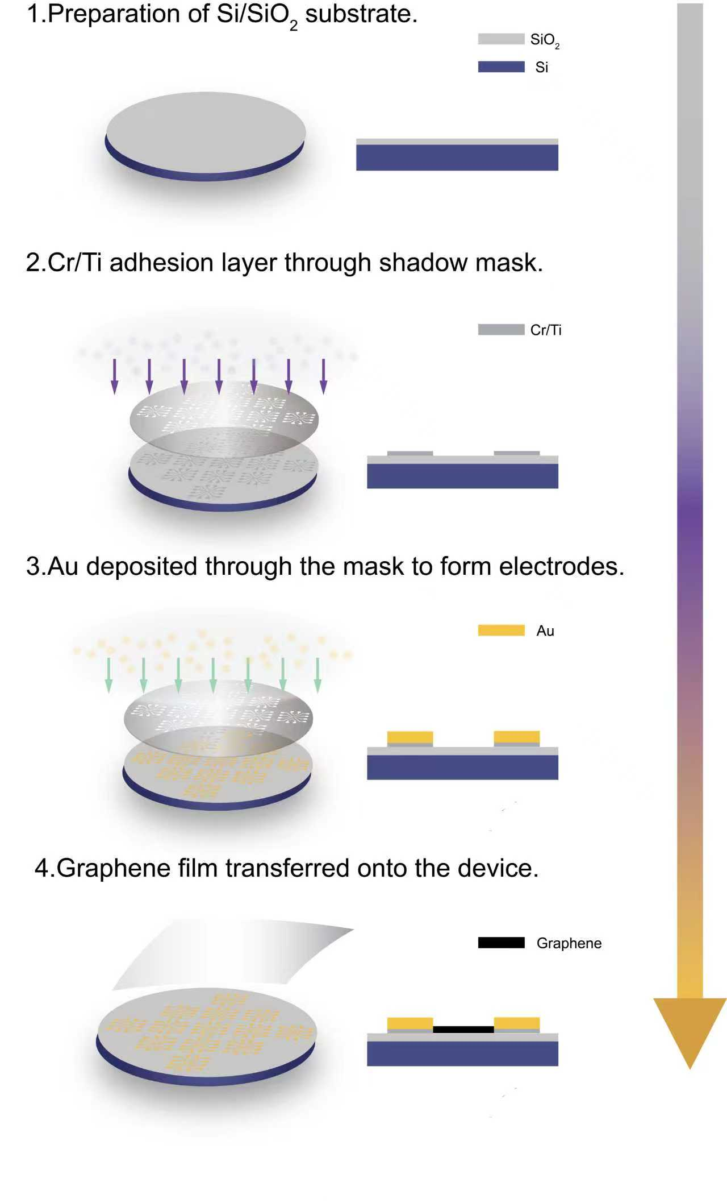
Figure S1. Sensor Fabrication. Illustration of the fabrication and detection process of the GFET biosensor.

Figure S2.
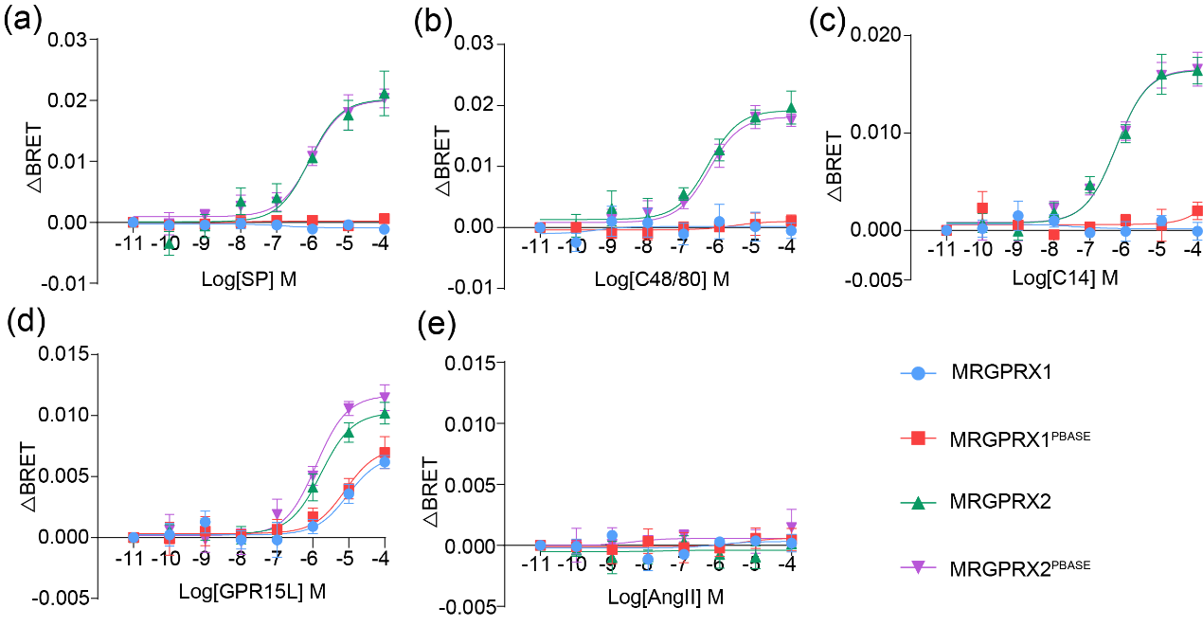
Figure S2. FlAsH-BRET characterization of ligand selectivity and signaling parameters for free and PBASE-covalently conjugated MRGPRX2 and MRGPRX1.
(a-e) Representative dose response curve of the different ligand (a: SP, b: C48/80, c: C14, d: GPR15L, e: AngII) induced BRET ratio in free or PBASE-covalently.

Figure S3.
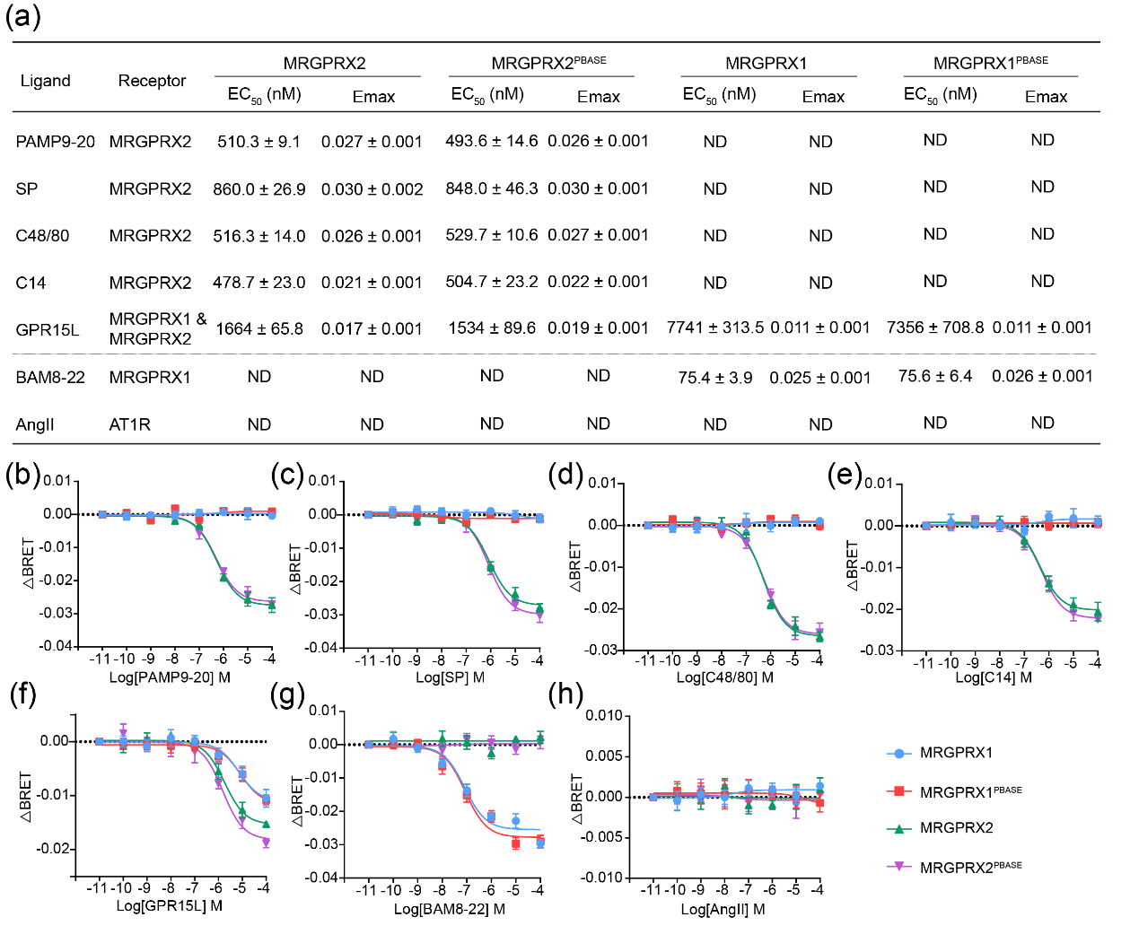
Figure S3 Gi signaling characterization of ligand selectivity for free and PBASE-covalently conjugated MRGPRX2 and MRGPRX1.
(a) Tabulated EC50​ and Emax​ values from dose-response fitting of Gi signaling for all ligand–receptor combinations; ND indicates no detectable receptor activation. Ligand panel covers MRGPRX2-specific agonists (PAMP9-20, SP, C48/80, C14), MRGPRX1 agonist BAM8-22, dual-agonist GPR15L, and off-target AngII negative control.
(b–e) Representative dose response curve of Gi dissociation in MRGPRX2 and MRGPRX1 overexpressing HEK293 cells (free or PBASE-covalently) in response to stimulation with different ligand (b: PAMP9-20, c: SP, d: C48/80, e: C14, f: GPR15L, g: BAM8-22, h: AngII). Data are presented as mean ± S.E.M.

Figure S4.
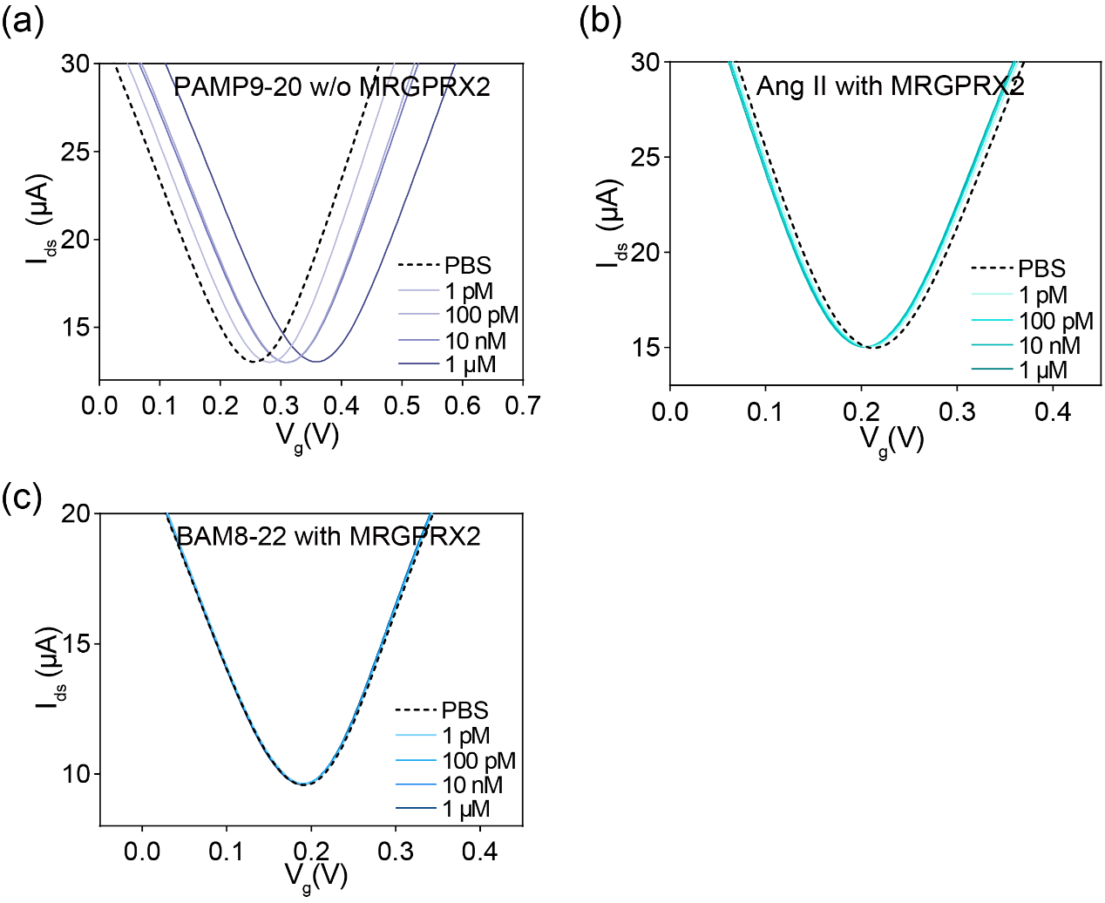
Figure S4. Electrical characterization of different ligands.
(a) Transfer characteristic curves measured when GFET-Based itch-receptor biosensor was exposed to different PAMP9-20-concentrations in PBS.
(b) Transfer characteristic curves measured when GFET without itch-receptor biosensor was exposed to different AngⅡ-concentrations in PBS.
(c) Transfer characteristic curves measured when GFET without itch-receptor biosensor was exposed to different BAM8-22-concentrations in PBS.

Figure S5.
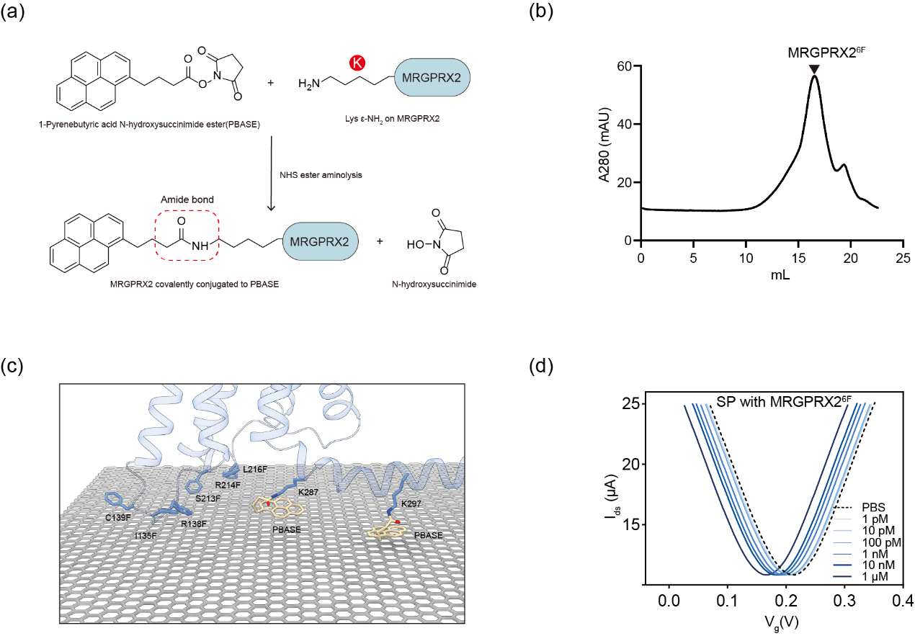 Figure S5. Characteristics of MRGPRX2^{6F}.
(a) Reaction scheme of the NHS ester aminolysis between PBASE and MRGPRX2. The NHS ester of PBASE reacts with the ε-amino group of surface lysine residues on MRGPRX2 to form a covalent amide bond (red dashed box), with N-hydroxysuccinimide released as the leaving group.
(b) Representative elution profiles of in vitro reconstituted MRGPRX2^{6F} on a Superdex 200 Increase 10/300 column and SDS-PAGE results of the size-exclusion chromatography peak.
(c) Binding mode of the MRGPRX2^{6F} (I135F, R138F, C139F, S213F, R214F, and G215) –PBASE–graphene complex. The receptor is covalently linked to the PBASE molecule via lysine residues at the intracellular surface, and the pyrene group of PBASE anchors onto the graphene sheet through π–π stacking interactions.
(d) Transfer characteristic curves measured when MRGPRX2^{6F}-GFET itch-receptor biosensor was exposed to different SP-concentrations in PBS.

Figure S6.
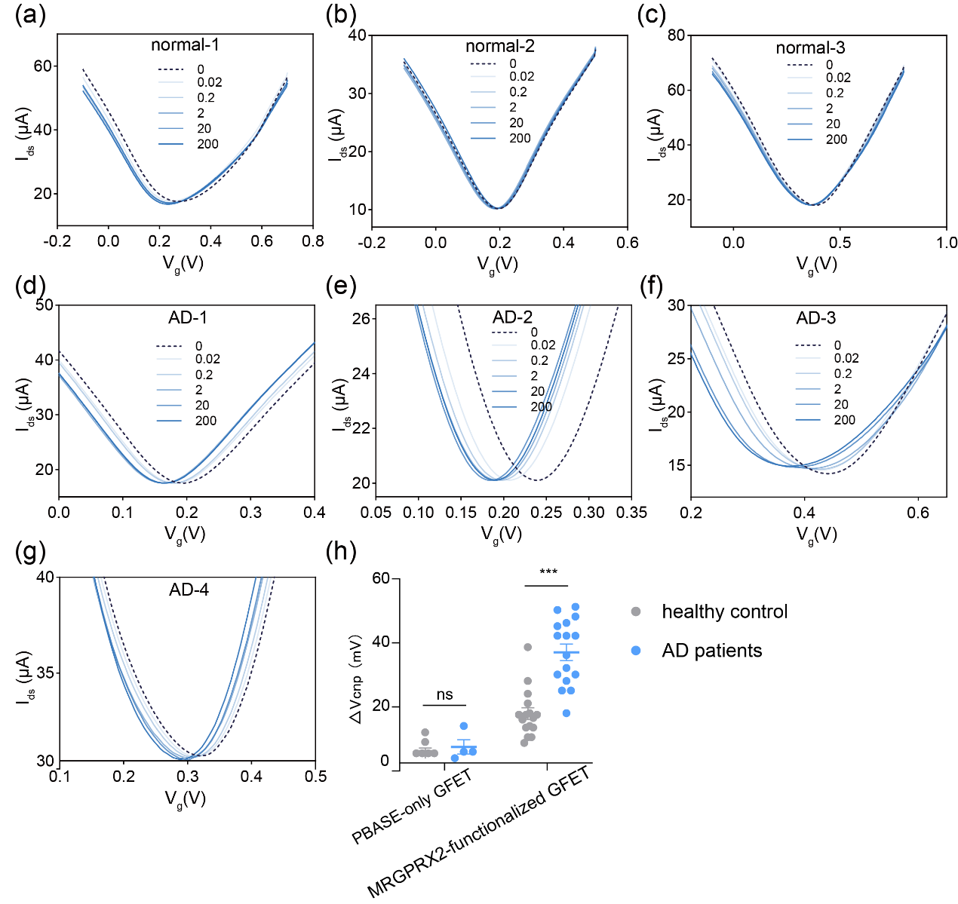
Figure S6. Characterization and Biomarker Detection in Clinical Human HLB-column-fractionated blood plasma.
(a-g) Transfer characteristic curves measured when the GFET-based itch-receptor biosensor was exposed to clinical samples ranging from 0 to 200 ng/μL from healthy individuals and AD patients.
(h) Compared with the MRGPRX2–GFET biosensor, the control PBASE-only GFET device exhibited a negligible Dirac point shift (ΔV_{cnp}) when exposed to the complex plasma samples. Each open circle represented an independent sample point. The bars indicated the mean ± SEM values. Data was statistically analyzed using two-way ANOVA with Dunnett’s post hoc test. (h) ***P < 0.001, ns, no significance, AD patients were compared with healthy controls in PABSE-only GFET and MRGPRX2-functionalized GFET.
Figure S7.
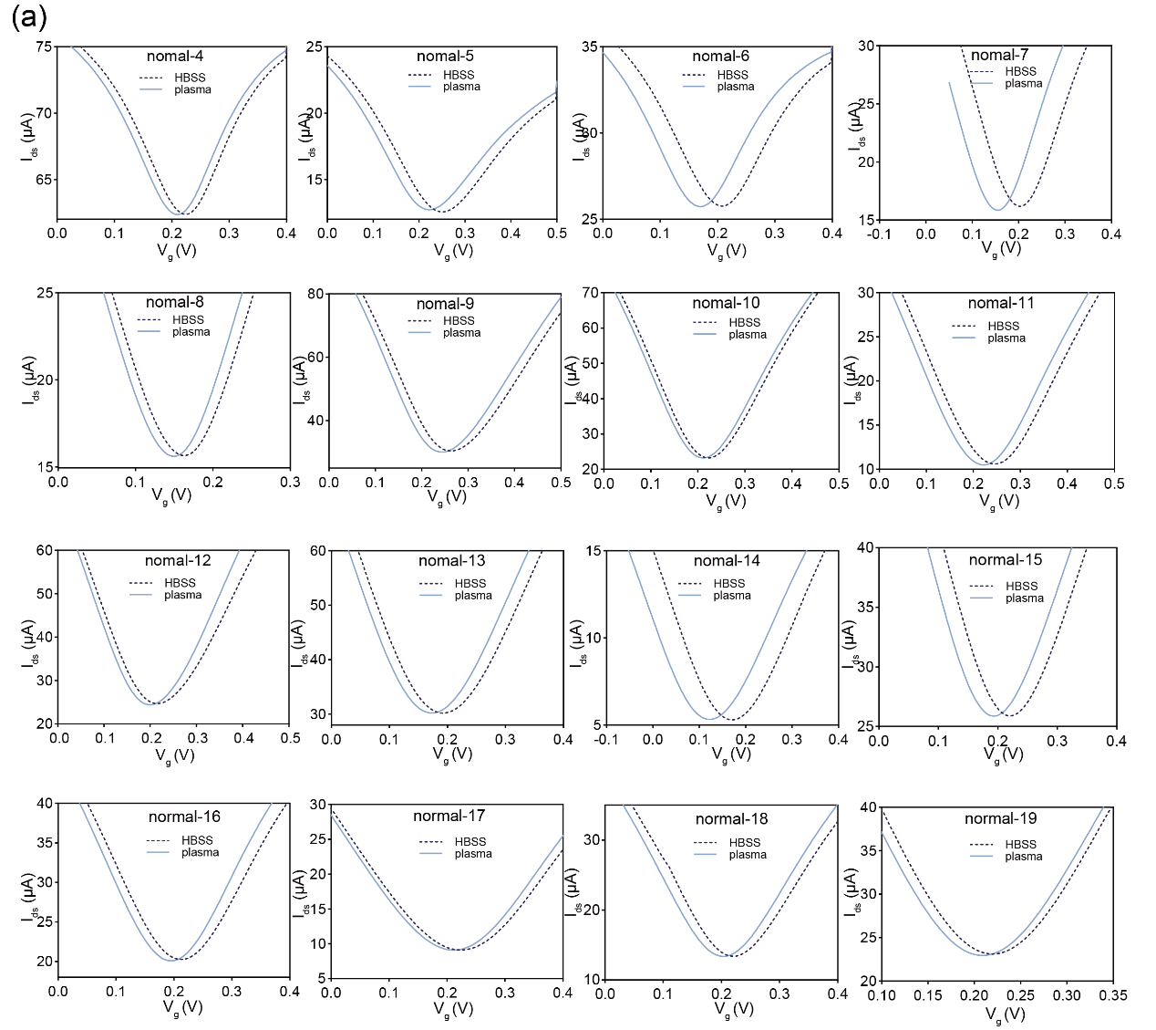
Figure S7. Characterization and Biomarker Detection in Clinical Human Plasma Samples.
(a) Transfer characteristic curves measured when the GFET-based itch-receptor biosensor was exposed to clinical human plasma samples from healthy individuals.

Figure S8.
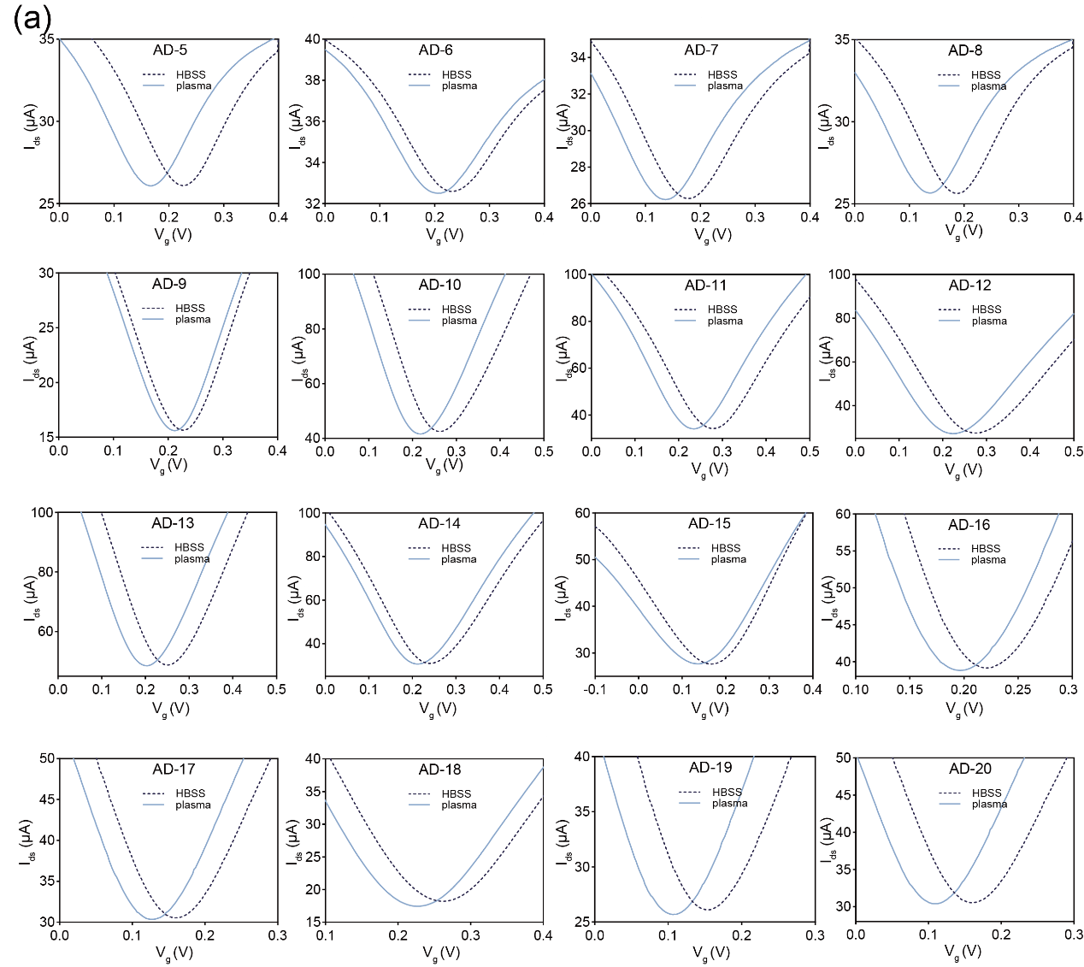
Figure S8. Characterization and Biomarker Detection in Clinical AD Patients Plasma Samples.
(a) Transfer characteristic curves measured when the GFET-based itch-receptor biosensor was exposed to clinical human plasma samples from AD patients.

Table S1. Summary of EASI score and activation potency of MRGPRX2 of healthy individuals and AD patients, relating to Figure. S6-S8.
Participants | Gender | EASI score
Healthy-1 | female | -
Healthy-2 | male | -
Healthy-3 | male | -
Healthy-4 | female | -
Healthy-5 | male | -
Healthy-6 | female | -
Healthy-7 | female | -
Healthy-8 | male | -
Healthy-9 | female | -
Healthy-10 | female | -
Healthy-11 | female | -
Healthy-12 | male | -
Healthy-13 | male | -
Healthy-14 | male | -
Healthy-15 | female | -
Healthy-16 | female | -
Healthy-17 | male
Healthy-18 | male
Healthy-19 | female
AD-1 | male | 54
AD-2 | male | 44.1
AD-3 | male | 26.1
AD-4 | female | 42.6
AD-5 | male | 39.6
AD-6 | male | 2.4
AD-7 | female | 40.8
AD-8 | female | 34.1
AD-9 | female | 34.4
AD-10 | male | 41.5
AD-11 | female | 21.2
AD-12 | male | 41.2
AD-13 | male | 10.2
AD-14 | female | 28.1
AD-15 | female | 39.6
AD-16 | female | 12
AD-17 | female | 26.4
AD-18 | female | 48
AD-19 | male | 5.3
AD-20 | male | 2.4

