Supplemental Material
Data imputation
Biomarker data that are continuous in nature but are less than the lower limit of quantification (LLOQ) or above the upper limit of quantification (ULOQ) were imputed as follows: A value that was 1 unit less than the LLOQ was used for calculation of descriptive statistics if the datum was reported in the form of “<x” (where x is considered the LLOQ) or if the provided numerical value was less than LLOQ. An exception to this rule is any value reported as <1 or <0.1, etc. For values reported as <1 or <0.1, a value of 0.9 or 0.09, respectively, was used for calculation of summary statistics. A value that was 1 unit above the ULOQ was used for calculation of descriptive statistics if the datum was reported in the form of “>y” (where y is considered the ULOQ) or provided value was >ULOQ. Values with decimal points followed the same rules. The LLOQ and ULOQ were used for calculation of descriptive statistics if the datum was reported in the form of “≤x” or “≥y” (where x and y are the LLOQ and ULOQ, respectively). For consistency, LLOQ and ULOQ values were defined using the same number of significant digits as reported by the contract research organization for the respective biomarker assay.
Determination of assay to measure serum IL-31
Four commercially available IL-31 ELISA assays were tested on samples from HVs and AD patients to validate the assay performance on human samples. In the measurement by Luminex and MSD V-PLEX, only one AD patient with the highest SCORAD score (87) had detectible serum IL-31 levels in MSD V-PLEX, with most samples being below LLOQ. Using the DuoSet IL-31 ELISA, 4/5 (80%) samples from the healthy volunteers yielded detectible serum IL-31 levels (2,000 pg/mL to>ULoQ [1 ug/mL]). However, the detected serum IL-31 levels dropped to levels below LLOQ after applying heterophilic blocking reagent in the plasma samples, suggesting a false-positive signal from donor samples possibly contaminated with heterophilic antibodies. The Quanterix Simoa IL-31 assay was able to detect serum IL-31 in most of the AD patients (25/35, 71%) with a mild correlation with SCORAD score (data not shown). Therefore, the Quanterix Simoa IL-31 assay was used to measure serum IL-31 levels in patients enrolled in the clinical studies. Prior to testing samples, the Quanterix Simoa IL-31 assay was analytically validated by Myriad RBM (Austin, TX) by characterizing the quantitation limits (LLoQ and ULoQ), precision, spike-recovery, linearity, matrix interference, freeze-thaw stability, and short-term analyte stability.

Supplemental Table 1: Demographic information from commercially acquired NASH and PSC samples for IL-31 in situ hybridization
NASH samples
Fibrosis stage | F0 | 7
 | F1 | 24
 | F2 | 10
 | F3 | 10
 | F4 | 7
Gender | Female, n (%) | 24/58 (41)
 | Male, n (%) | 19/58 (33)
 | Not identified, n (%) | 15/58 (26)
Age | Years, median (IQR) | 51 (36, 80)
PSC samples
Gender | Female, n (%) | 6/13 (46.2)
 | Male, n (%) | 6/13 (46.2)
 | Not identified, n (%) | 1/13 (7.7)
Age | Year, median (IQR) | 54 (38, 64)
Race | Not Hispanic or Latino, n (%) | 11/13 (84.6)
 | Not identified | 2/13 (15.4)
IL, interleukin; IQR, interquartile range; mRNA, messenger RNA; NASH, nonalcoholic steatohepatitis; PSC, primary sclerosing cholangitis.

Supplemental Table 2: Correlations between serum autotaxin levels with VAS and 5-D Itch in patients with PSC.

 | Baseline | Spearman Correlations (ρ) | P-value
CILO PSC study (NCT02943460) | ATX vs 5-D Itch | 0.43 | 0.0014
 | ATX vs VAS | 0.33 | 0.016

ATX, autotaxin; CILO, cilofexor; IL, interleukin; PSC, primary sclerosing cholangitis; VAS, visual analog scale.

Supplementary Figure 1: Study design of cilofexor Phase 2 studies
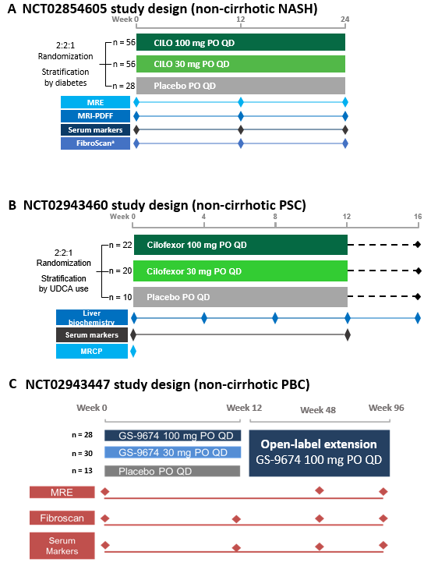
ªEchosens™, Paris, France.
BL, baseline; CILO, cilofexor; MRCP, magnetic resonance cholangiopancreatography; MRE, magnetic resonance elastography; MRI-PDFF, magnetic resonance imaging‒proton density fat fraction; NASH, nonalcoholic steatohepatitis; PBC, primary biliary cirrhosis; PO, by mouth; PSC, primary sclerosing cholangitis; QD, once daily; UDCA, ursodeoxycholic acid.
Supplementary Figure 2: Cilofexor did not change autotaxin levels in NASH patients
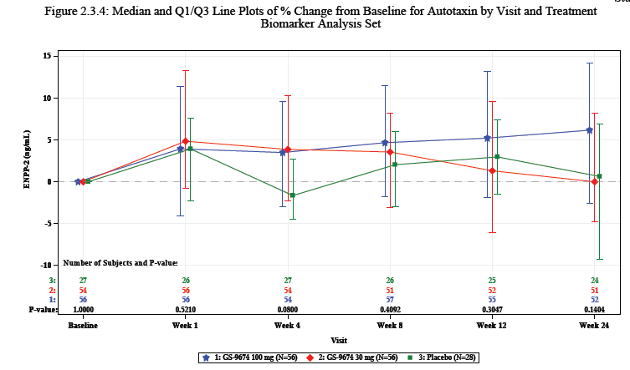
Supplementary Figure 3: IL-31 and FGF-19 levels in healthy volunteers and NASH patients administered cilofexor
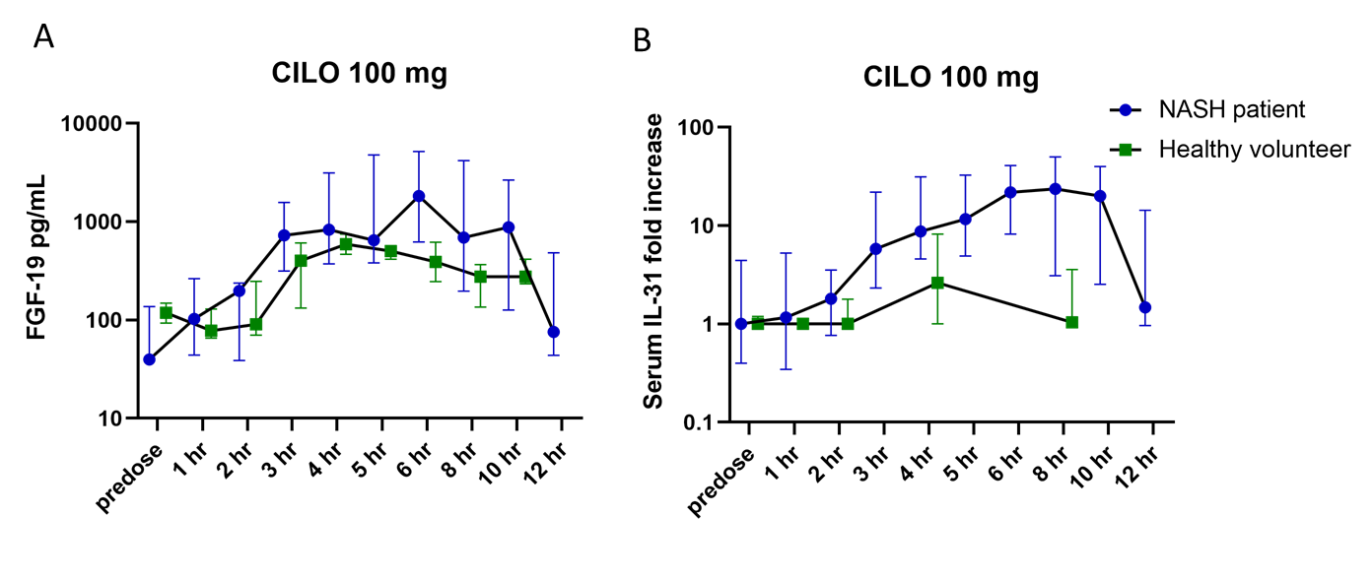
CILO, cilofexor; FGF, fibroblast growth factor; IL, interleukin; NASH, nonalcoholic steatohepatitis.

Supplementary Figure 4: Cilofexor did not change visual analog scale or 5-D Itch scores in PSC and PBC patients
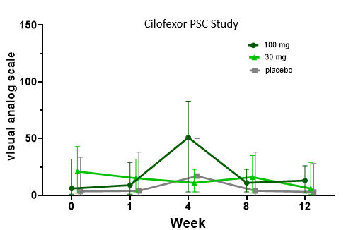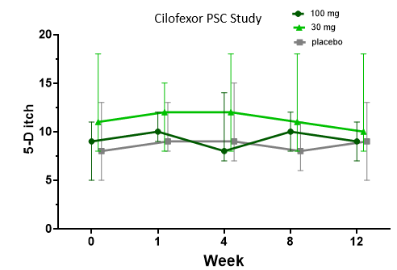
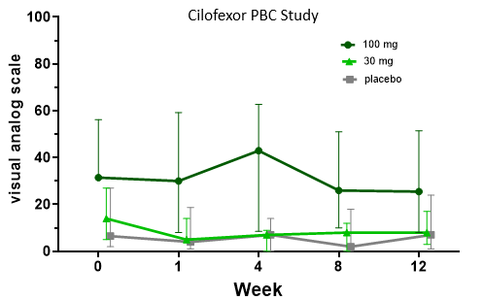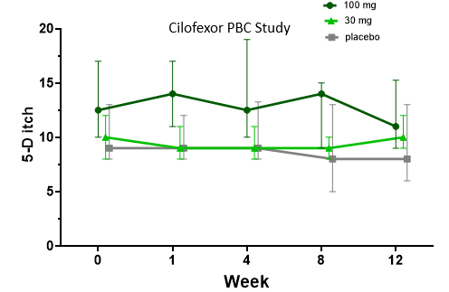

PSC, primary sclerosing cholangitis; PBC, primary biliary cholangitis

Supplementary Figure 5: Change in serum IL-4 levels in NASH and PSC patients given cilofexor
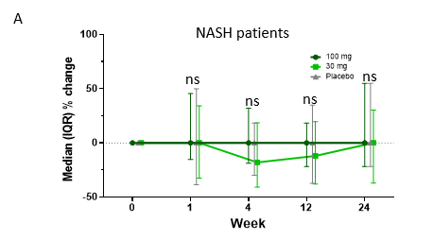
 | CILO 100 mg (n = 56) | CILO 30 mg (n = 56) | Placebo (n = 28)
Week 1 | 0 (–15.4, 45.5) | 0 (–32.6, 34.1) | 0 (–38.6, 50)
Week 4 | 0 (–18.8, 32.1) | –18 (–40.9, 18.6) | 0 (–29.9, 18.2)
Week 12 | 0 (–21.9, 18.2) | –12.0 (–38.0, 19.7) | 0 (–27.3, 34.8)
Week 24 | 0 (–21.9, 55.0) | 0 (–37.1, 30.3) | 0 (–21.9, 55.0)

 | CILO 100 mg (n = 16) | CILO 30 mg (n = 12) | Placebo (n = 5)
Week 1 | –21 (–33, 9) | –22 (–31, –5) | –9 (–3.7, –9.7)
Week 4 | –3 (–40, 31) | 3 (–24, 25) | 7 (–5, 10)
Week 12 | –9 (–31, 10) | –9 (–36, –2) | -17 (–24, –4)
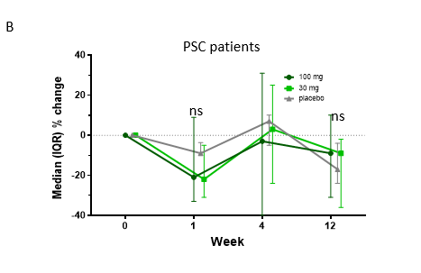

CILO, cilofexor; IL, interleukin; IQR, interquartile range; NASH, nonalcoholic steatohepatitis; ns, not significant; PSC, primary sclerosing cholangitis.

Supplementary Figure 6: Simoa assay detected human, but not mouse IL-31
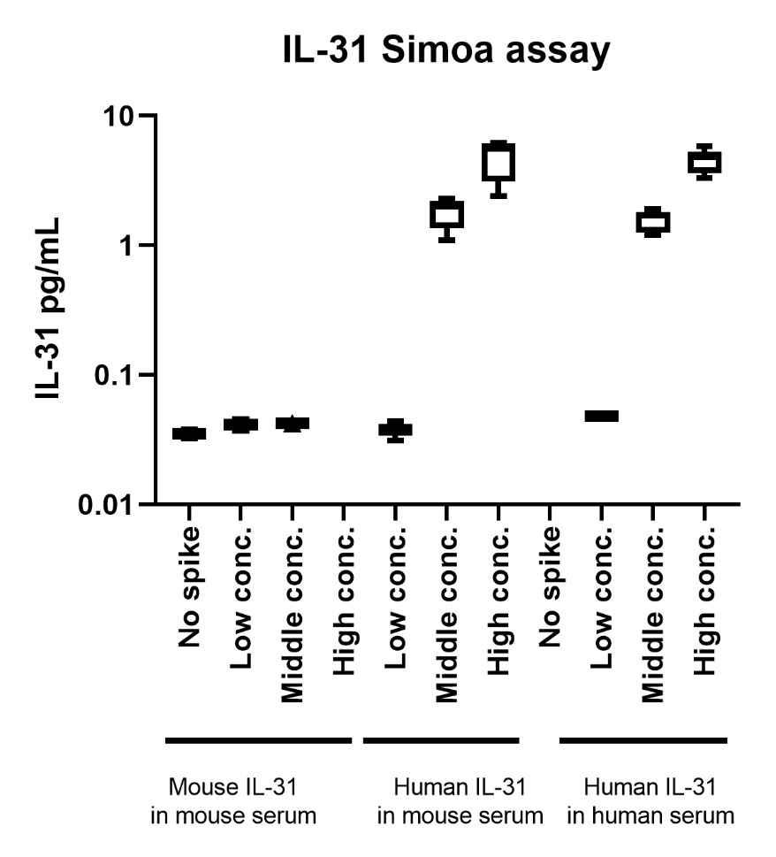
Conc., concentration; IL, interleukin.

Supplementary Figure 7: IL-31 in situ hybridization in ileum samples from HVs and skin from patients with atopic dermatitis (AD)
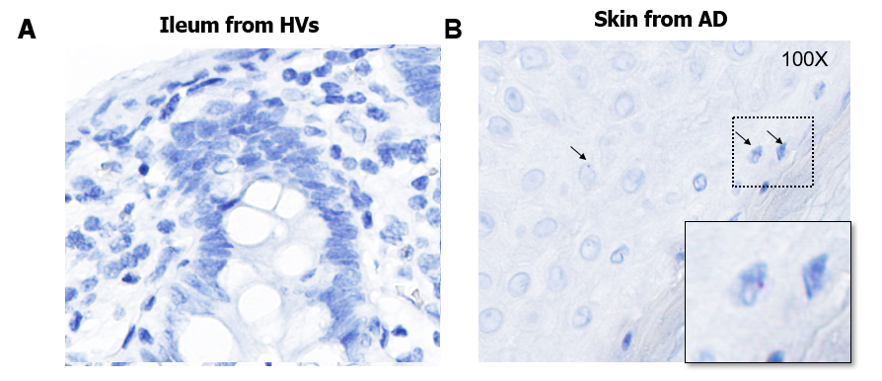

Supplementary Figure 8: Identification of IL-31 negative and positive nuclei
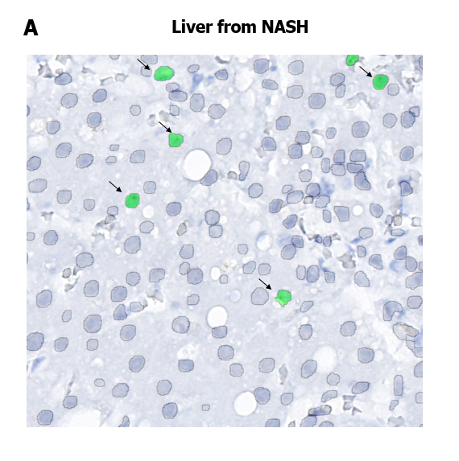
Circles: IL-31 negative nuclei
Green: IL-31 positive nuclei

