Supplementary Information

iPSC-derived human sensory neurons reveal a subset of TRPV1 antagonists as anti-pruritic compounds

Shermaine Huiping Tay¹, Jeremy Kah Sheng Pang¹, Winanto Ng¹, Chong Yi Ng¹, Zi Jian Khong¹, Zheng-Shan Chong¹, Boon Seng Soh¹, Shi-Yan Ng^{1,2,3}

¹ Institute of Molecular and Cell Biology (IMCB), Agency for Science, Technology and Research (A*STAR), 61 Biopolis Drive, Proteos, Singapore 138673, Republic of Singapore.
² National University of Singapore, Yong Loo Lin School of Medicine (Physiology), Singapore 117456
³ National Neuroscience Institute, Singapore 308433

Correspondence to: Shi-Yan Ng (syng@imcb.a-star.edu.sg)

Supplementary Figures

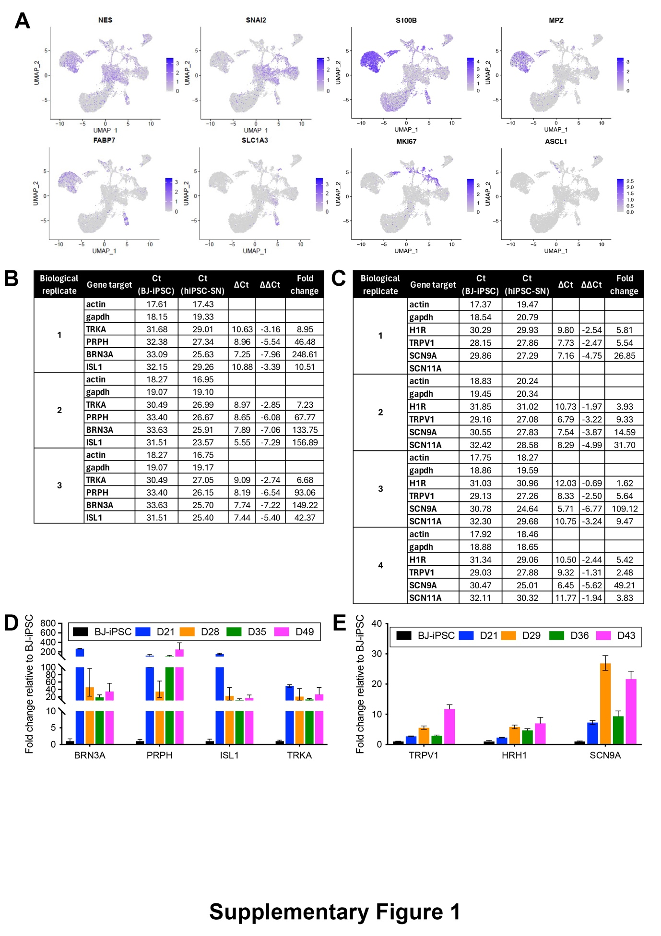
Supplementary Figure 1

Supplementary Figure 1. Characterization of hiPSC-SNs. (A) UMAP plots of the expression of gene markers that were used to label neural crest progenitor cells (NES and SNAI2), Schwann cell clusters (MPZ and S100B), satellite glia cells (FABP7 and SLC1A3), proliferating cells (MKI67) and immature neuron clusters (ASCL1). (B, C) qPCR analysis showing raw Ct, ΔCt, ΔΔCt values and fold changes of SN canonical markers, i.e. TRKA, PRPH, BRN3A and ISL1 at day 15 post differentiation (B) and of H1R/TRPV1 signalling pathway elements, i.e. H1R, TRPV1, SCN9A and SCN11A at day 28 post differentiation (C) in BJ-iPSC controls and in hiPSC-SNs. (D) qPCR analysis in hiPSC-SNs showing upregulation of SN canonical markers, i.e. TRKA, PRPH, BRN3A and ISL1 relative to undifferentiated BJ-iPSC controls from day 21 to 49 post differentiation. Gene expression was normalized to ACTINB and GAPDH. (E) qPCR analysis in hiPSC-SNs showing upregulation of H1R/TRPV1 signalling pathway elements, i.e. H1R, TRPV1 and SCN9A relative to undifferentiated BJ-iPSC controls from day 21 to 43 post differentiation, respectively. Gene expression was normalized to ACTINB and GAPDH.

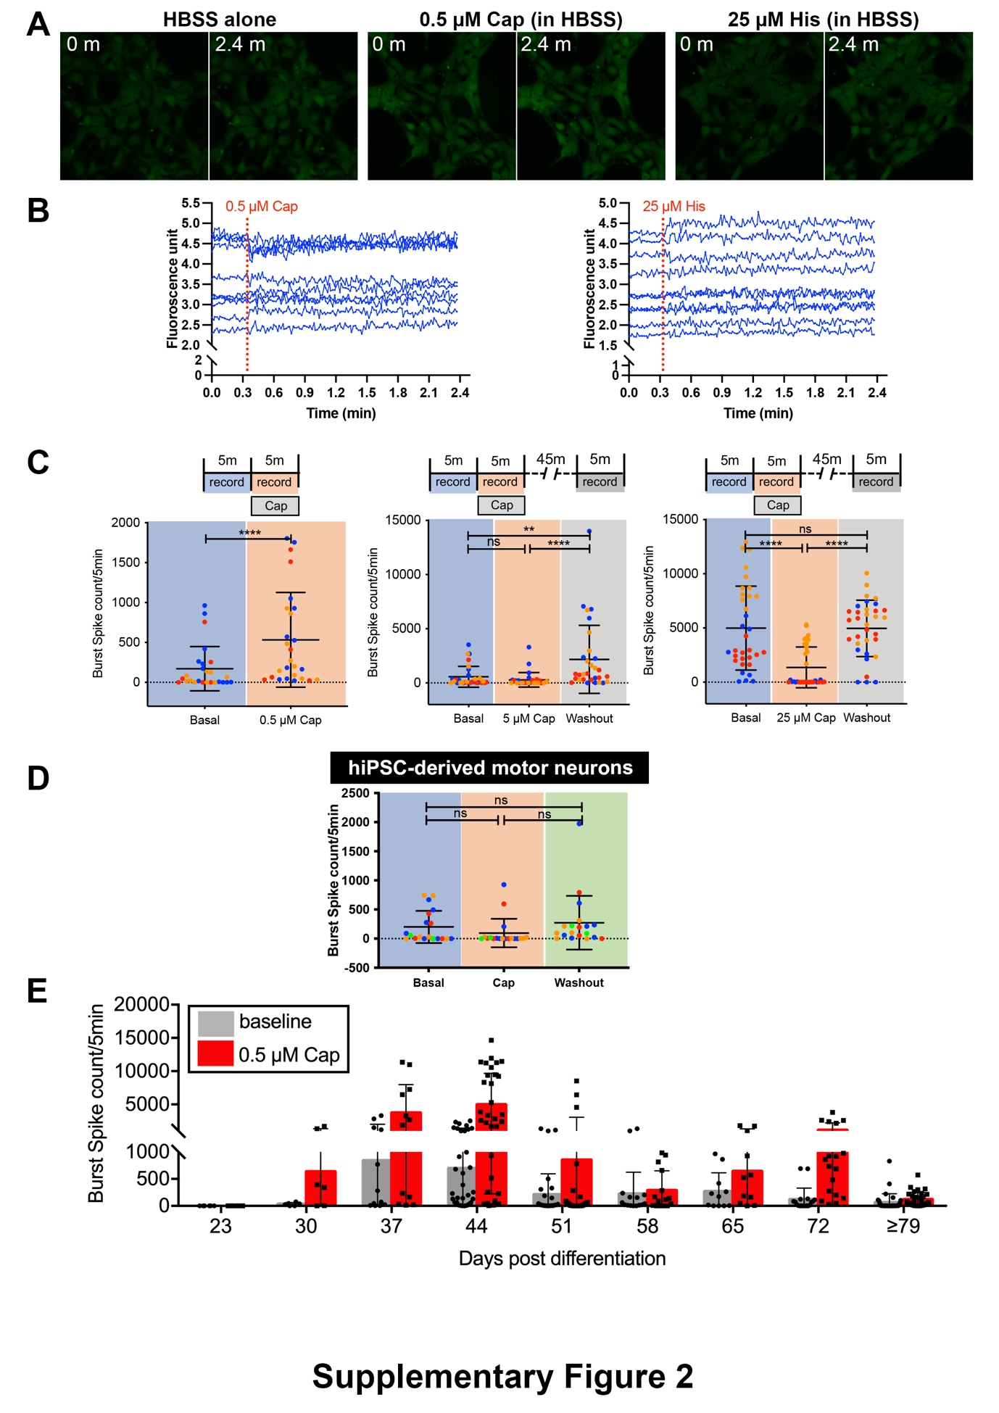
Supplementary Figure 2

Supplementary Figure 2. TRPV1 channels respond to capsaicin as early as day 23 and till day 90 in hiPSC-SNs. (A) Representative calcium intensities of BJ-iPSC cells captured at the initial and final frames of treatment in response to HBSS alone, the TRPV1 agonist capsaicin (Cap), or the H1R agonist histamine (His) using an EVOS M5000 Imaging System. (B) Time trace of fluorescence change in calcium influxes across the entire BJ-iPSC population were recorded in 9 wells in response to either TRPV1 agonist, i.e. capsaicin (Cap) or H1R agonist, i.e. histamine (His) using a Varioskan LUX Multimode Microplate Reader. (C) Assessment of MEA-based burst spike counts in hiPSC-SNs in response to increasing concentrations (0.5, 5 and 25 μM) of capsaicin. 0.5 μM capsaicin triggered an increase in burst spike events while 5 and 25 μM capsaicin resulted in no difference and a decrease, respectively. Subsequent recovery of spontaneous burst spike events following removal of 5 and 25 μM capsaicin supports a dosage-dependent acute desensitizing response in TRPV1 channels. Data is shown as means ± SD, ^{ns}P > 0.05, *P ≤ 0.05, **P ≤ 0.01, ***P ≤ 0.001, ****P ≤ 0.0001, Wilcoxon matched-pairs signed rank test and Friedman test with Dunn’s multiple comparisons test, N=1-3 independent biological differentiations (colour-coded as either blue, red or orange spots) in all experimental set-ups. (D) MEA measurements demonstrating no difference in hiPSC-derived motor neurons’ burst spike events in response to stimulation with TRPV1 agonist, i.e. capsaicin. Data is shown as means ± SD, ^{ns}P > 0.05, *P ≤ 0.05, **P ≤ 0.01, ***P ≤ 0.001, ****P ≤ 0.0001, Friedman test with Dunn’s multiple comparisons test, N=1-4 independent biological differentiations (colour coded as either blue, red, orange or green spots) in all experimental set-ups. (E) Weekly assessment of MEA-based burst spike counts in hiPSC-SNs at baseline and in response to 0.5 μM capsaicin stimulation from day 23 to day 90 of culturing. An increase in burst spike events relative to baseline as early as day 30 and lasting till day 79 supports the presence of functional matured TRPV1 channels.

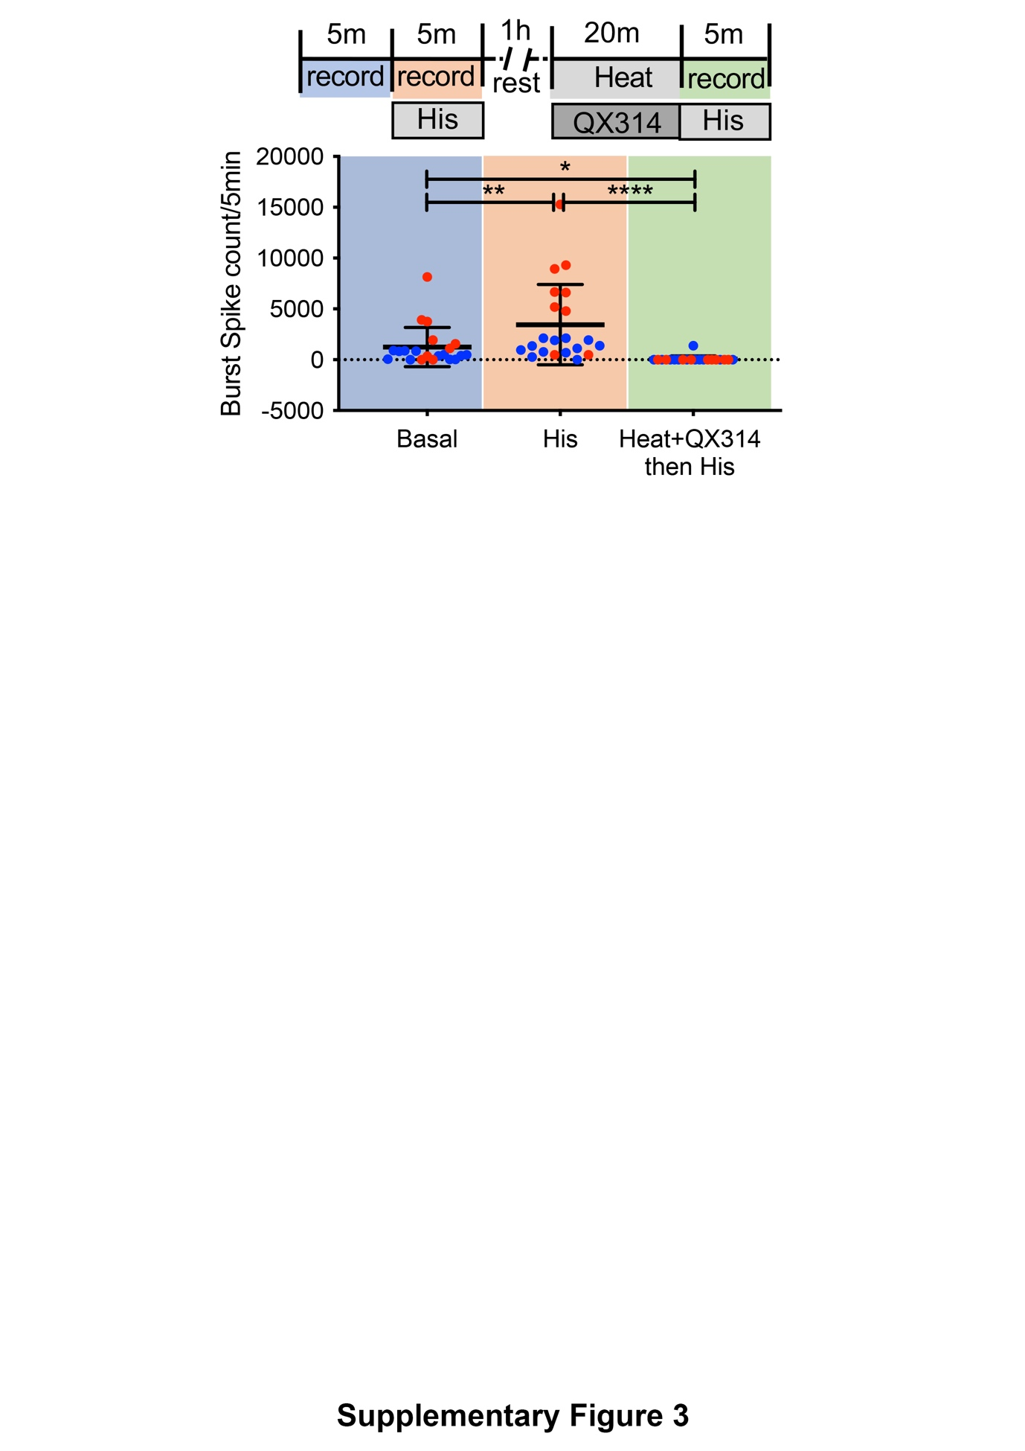
Supplementary Figure 3

Supplementary Figure 3. Noxious heat and QX-314-mediated inhibition of TRPV1 channels in hiPSC-SNs blocks histamine activation. Co-administration of heat (42°C) and sodium channel blocker, i.e. QX 314 followed by a subsequent stimulation with histamine reveals a suppression in histamine response in MEA analysis. Data is shown as means ± SD. ^{ns}P > 0.05, *P ≤ 0.05, **P ≤ 0.01, ***P ≤ 0.001, ****P ≤ 0.0001, Friedman test with Dunn’s multiple comparisons test, N=2 independent biological differentiations (colour coded as blue and red spots) in all experimental set-ups. For each independent differentiation, all active electrode channels recording at multiple locations of a single hiPSC culture well are indicated as spots of the same colour.

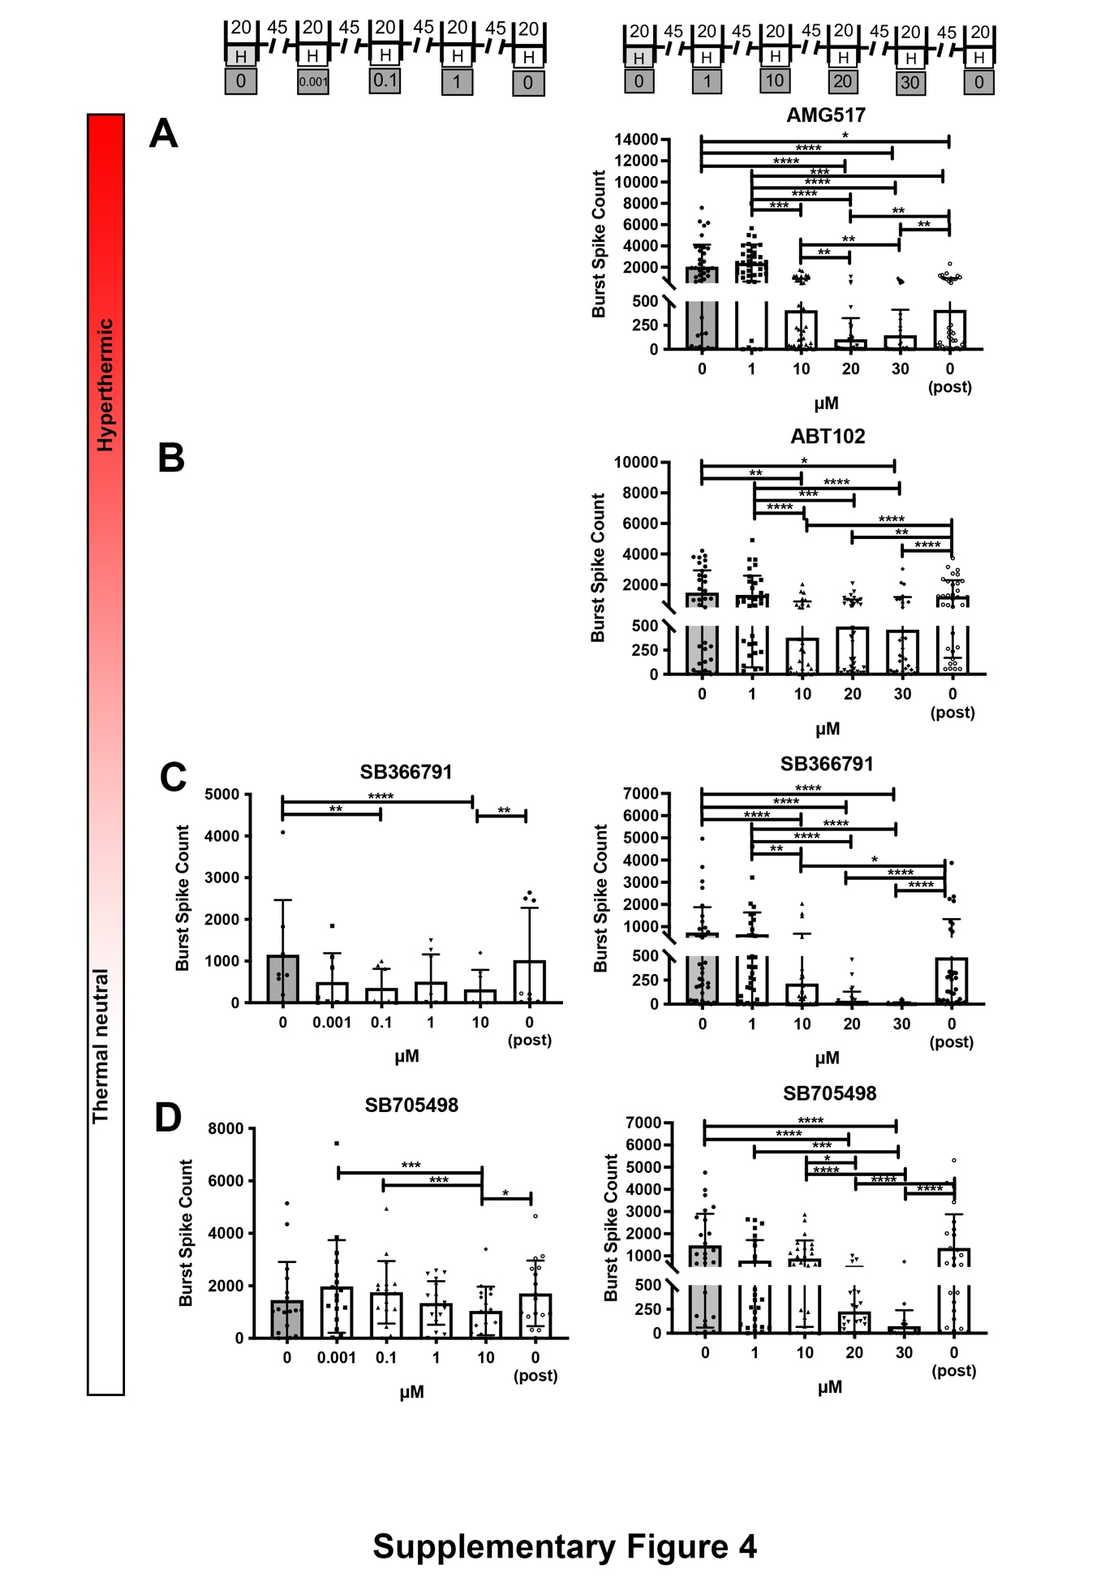

Supplementary Figure 4

Supplementary Figure 4. Determination of TRPV1 antagonists’ therapeutic doses by their efficacies to block heat activation of TRPV1 in hiPSC-SNs. (A-D) Dose-dependent effects of hyperthermia-inducing TRPV1 antagonists, i.e. AMG517 (A) and ABT102 (B) and hyperthermia-free TRPV1 antagonists, i.e. SB366791 (C) and SB705498 (D) on TRPV1 blockage in heat (42°C) activation mode. Heat responses were assessed as MEA burst spike events occurring only in the 9th minute of the heating regime (in Fig. 2F) in response to pre-treatment (0 μM), then to increasing doses of antagonists between 0.001 and 30 μM and again after antagonist removal (0 μM). Only significant comparisons relative to the pre-treated (0 μM) condition is indicated here. Data is shown as means ± SD. ^{ns}P > 0.05, *P ≤ 0.05, **P ≤ 0.01, ***P ≤ 0.001, ****P ≤ 0.0001, RM one-way ANOVA (A) and Friedman test with Dunn’s multiple comparisons test (A-D), N=1 independent biological differentiation in all experimental set-ups.

Supplementary Table S1: Primer sequences used for qPCR

Gene | Forward primer sequence (5’ 3’) | Reverse primer sequence (5’ 3’)
ACTINB | CCAACCGCGAGAAGATGA | CCAGAGGCGTACAGGGATAG
GADPH | AGCCACATCGCTCAGACAC | GCCCAATACGACCAAATCC
BRN3A | AGTACCCGTCGCTGCACTCCA | TTGCCCTGGGACACGGCGATG
GNAQ | GATCAGAGCCATGGACACACTC | GCAGACACCTTCTCCACATCAAC
GNA11 | CCTCAGCGAATACGACCAAGTC | ATGACGGAGGAGTTCTGGAACC
H1R | CCAAGAGTGGTGGCAGCTCA | GCACGGGAACTCCATGTCAG
ISL1 | GTGGAGAGGGCCAGTCTAGG | CCGTCATCTCTACCAGTTGCT
PRPH | GAGGAGCTGCGACAGCTAAA | ACCTCAGGCACAGTCGTCTT
SCN9A | ACCTATCTCTGCTTCAAGTTGC | TGGGCTGCTTGTCTACATTAAC
SCN11A | CCTGTATGGTCAGATGAGGCTC | CATCACACAACCTGAGCCTGAAC
TRKA | CACTAACAGCACATCTGGAGACC | TGAGCACAAGGAGCAGCGTAGA
TRPV1 | GAGTTTCAGGCAGACACTGGAA | CTATCTCGAGCACTTGCCTCTCT

